Prior Knowledge and Skills
Cooking:
 | - Develop an understanding of healthy and unhealthy food
 | - Follow a simple recipe
 | - Make a beetroot oaty bar





DT – Healthy Eating Recipe (Year 1)

Outcome: Make lettuce bruschetta.

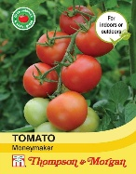
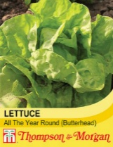
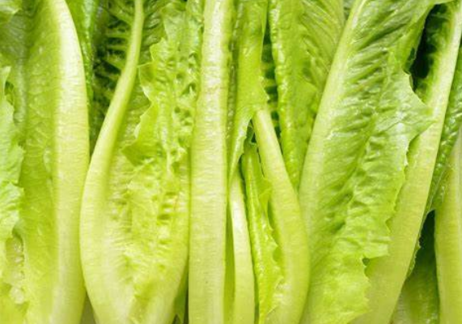
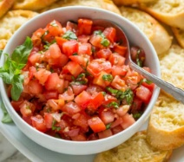
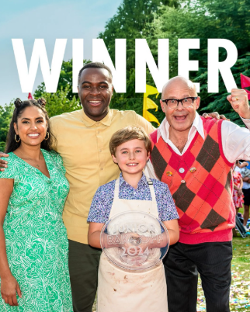
Vocabulary:
- prepare
- make
- evaluate
- healthy
- varied
- ingredients
- equipment
- recipe
- growing
- choosing
- blending
- cutting
- sensory vocabulary
e.g. soft smooth crunchy
- clean

Ideas and inspiration:
Junior Bake Off Winner 2024
11-Year-old Austin
Growing from seed:
tomatoes and lettuce

Developing Knowledge and Skills
Knowledge: |  | Working Towards | Within | Securely Within | Above
 | - Discuss and explore Junior Bake Off
 | - Understand how Junior Bake Off helps shape baking, cooking and healthy eating
Design: |  | Working Towards | Within | Securely Within | Above
 | - Grow vegetables from seed
 | - Understand where a variety of food comes from
 | - Have a basic understanding of a healthy and varied diet
 | - Discuss the appropriate ingredients to make bruschetta
Make: |  | Working Towards | Within | Securely Within | Above
 | - Follow a simple recipe
 | - Make lettuce bruschetta
 | - Be clean and safe when cooking
Evaluate: |  | Working Towards | Within | Securely Within | Above
 | - Try the food
 | - Describe what the food tastes like
 | - Explore and evaluate the food through discussions
 | - Make suggestions for future improvements
Highlights: ______________________________________________________________________________________

_______________________________________________________________________________________________

