

DT – Puppet (Year 1)

Outcome: To sew a puppet.

Vocabulary:

- design
- make
- evaluate
- functional
- fabric
- needle
- eye
- thread
- knot
- running stitch
- textiles
- puppeteer

Ideas and inspiration:
Puppeteer Jim Henson with Kermit the Frog
https://kids.kiddle.co/Jim_Henson
English – Pinocchio https://kids.kiddle.co/Kermit_the_Frog
History – Toys

Completed puppet example

Running stitch

https://hopeandhart.com/2019/03/14/how-do-you-sew-running-stitch/

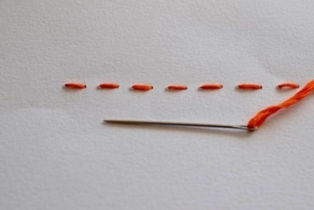
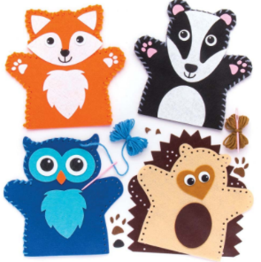
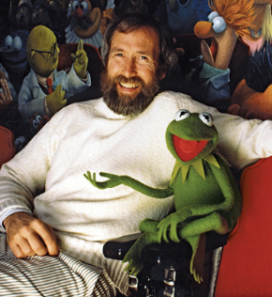
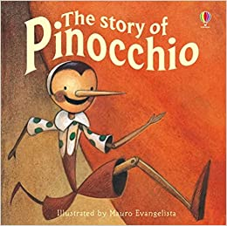

Developing Knowledge and Skills
Knowledge: |  | Working Towards | Within | Securely Within | Above
 | - To discuss and explore the puppet designer Jim Henson
 | - To understand how Jim Henson helped shape the toy industry by creating Kermit the Frog
Design: |  | Working Towards | Within | Securely Within | Above
 | - To plan and sketch simple ideas for a puppet
 | - To design a functional puppet and communicate ideas through talking and simple drawings
 | - To experiment using a running stitch
Make: |  | Working Towards | Within | Securely Within | Above
   | - To select and use a range of tools and equipment to cut, shape and sew a puppet
 | - To select and use a range of materials to make a functional puppet
  Evaluate: |  | Working Towards | Within | Securely Within | Above
 | - To explore and evaluate the design and make process through discussions
 | - To make suggestions for future improvements
The best bit about my puppet was___________________________________________________________________
_______________________________________________________________________________________________
My puppet would have been even better if ____________________________________________________________
________________________________________________________________________________________________
Highlights: _______________________________________________________________________________________
________________________________________________________________________________________________

