Prior Knowledge and Skills
Mechanisms:
 | - Discuss and explore the animator Walt Disney
 | - Discuss and explore the use of wheels, cams, axles and axle holders
 | - Make a functional moving river scene with aesthetic qualities


DT – Pneumatic Moving Dragon Head (Year 5)

Outcome: To create a mechanical moving dragon head.
Ideas and inspiration:
Maths – Nets
History – Viking Longship Dragon Head
Pneumatic Mechanism

Completed Pneumatic
Moving Dragon Head example
Julie Taymor – Costume Designer for
The Lion King Theatre Production

https://www.youtube.com/watch?v=_vZ8M4Dh4fg

Vocabulary:

- design
- make
- evaluate
- functional
- purposeful
- pneumatic
- mechanism
- net
- components
- fixed pivot
- loose pivot
- cut
- shape
- join
- aesthetic
- costume designer

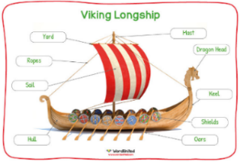
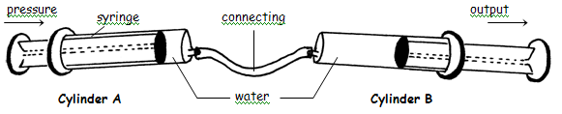
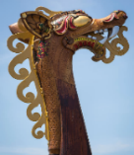
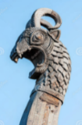
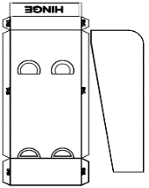
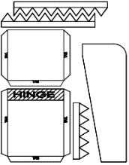
Developing Knowledge and Skills
Knowledge: |  | Working Towards | Within | Securely Within | Above
 | - To discuss and explore the costume designer Julie Taymor
 | - To understand how Julie Taymor helped develop and shape innovative set design and costumes within theatrical productions
Design: |  | Working Towards | Within | Securely Within | Above
 | - To plan and sketch innovative ideas for a moving dragon head
 | - To design and develop a purposeful and appealing dragon head with explanations and annotated diagrams
 | - To experiment using a pneumatic mechanism
 | - To explore and distinguish between fixed and loose pivots
 | - To develop and apply mathematical knowledge of nets
Make: |  | Working Towards | Within | Securely Within | Above
 | - To select the appropriate shapes, materials and components to build a pneumatic moving dragon head
 | - To accurately cut, shape and join the dragon head
 | - To make a functional pneumatic moving mechanism with aesthetic qualities
Evaluate: |  | Working Towards | Within | Securely Within | Above
 | - To test the moving mechanism
 | - To consider the views of others to make improvements
 | - To evaluate the positive stages of the design and make process
 | - To evaluate the challenges of the design and make process
 | - To make suggestions for future improvements
My DT learning in Year 4 help me because ___________________________________________________________ ______________________________________________________________________________________________
Highlights: _______________________________________________________________________________________
________________________________________________________________________________________________




