

DT – Cam Moving River Scene (Year 4)

Outcome: To create a moving river scene using a cam mechanism.

Prior Knowledge and Skills
Mechanisms:
 | - Experiment using levers and pivots
 | - Select and use a range of materials to make a functional mechanism
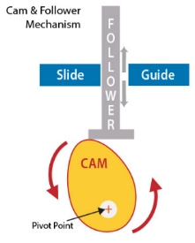
Ideas and inspiration:
Cam Mechanism
Geography – Rivers and the Water Cycle

Completed Moving River Scene
Walt Disney – Disney Animator

https://kids.kiddle.co/Walt_Disney

https://www.instructables.com/Fish-Automata/

Vocabulary:

- design
- make
- evaluate
- functional
- purposeful
- mechanism
- cam
- slide guide
- follower
- pivot point
- cut
- shape
- join
- dowelling
- aesthetic
- animator
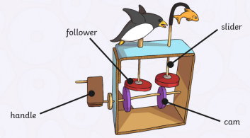
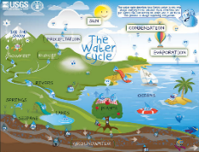
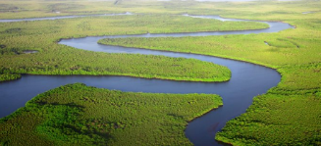
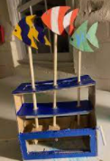

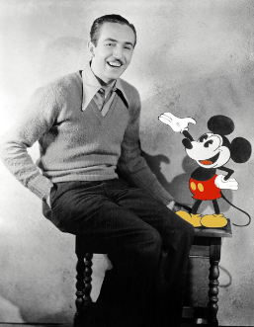
Developing Knowledge and Skills
Knowledge: |  | Working Towards | Within | Securely Within | Above
 | - To discuss and explore the animator Walt Disney
 | - To understand how Walt Disney helped develop and shape animation within the visual entertainment industry
Design: |  | Working Towards | Within | Securely Within | Above
 | - To plan and sketch realistic ideas for a moving river scene
 | - To design and develop a purposeful and functional river scene with explanations and annotated drawings
 | - To discuss and explore the use of wheels, cams, axles and axle holders
Make: |  | Working Towards | Within | Securely Within | Above
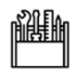 | - To successfully build a moving river scene using a cam mechanism
 | - To accurately cut, shape and join a moving river scene
 | - To make a functional moving river scene with aesthetic qualities
Evaluate: |  | Working Towards | Within | Securely Within | Above
 | - To test the moving mechanism
 | - To evaluate the positive stages of the design and make process
 | - To evaluate the challenges of the design and make process
 | - To make suggestions for future improvements
My DT learning in Year 1 help me because ___________________________________________________________ ______________________________________________________________________________________________
_______________________________________________________________________________________________
Highlights: _______________________________________________________________________________________
________________________________________________________________________________________________

