

DT – Moving Rainforest Animal (Year 2)

Outcome: To create a moving rainforest animal using a lever mechanism.

Prior Knowledge and Skills
Mechanisms:
 | - Experiment using sliders and levers
 | - Select and use a range of materials to make a mechanism

Vocabulary:

- design
- make
- evaluate
- functional
- purposeful
- mechanism
- pivot
- lever
- cut
- shape
Ideas and inspiration: Flying Rainforest Animals

Geography – Costa Rica

Completed Moving Rainforest Animal
Lever Mechanism

https://www.robives.com/project/lever/

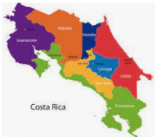
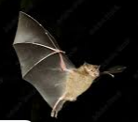
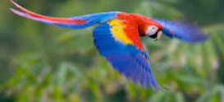

Developing Knowledge and Skills
Design: |  | Working Towards | Within | Securely Within | Above
 | - To plan and sketch simple ideas for a moving rainforest animal
 | - To design a functional rainforest animal and communicate ideas through talking and drawings
 | - To experiment using levers and pivots
Make: |  | Working Towards | Within | Securely Within | Above
 | - To select and use a range of tools and equipment to cut, shape and make a purposeful mechanism
 | - To select and use a range of materials to make a functional mechanism
Evaluate: |  | Working Towards | Within | Securely Within | Above
 | - To test the moving mechanism
 | - To explore and evaluate the design and make process through discussions
 | - To make suggestions for future improvements
The best bit about my animal was___________________________________________________________________
_______________________________________________________________________________________________
My animal would have been even better if ____________________________________________________________
________________________________________________________________________________________________
Highlights: _______________________________________________________________________________________
________________________________________________________________________________________________



