
Vocabulary:

- design
- make
- evaluate
- purposeful
- three-dimensional
- structure
- freestanding
- cut
- join
- shape
- nets
- cube
- cuboid
- architect

Ideas and inspiration:
Maths – Nets
History – The Great
Fire of London

Completed 3D Tudor House

Norman Foster –
Architect of The Gherkin

https://www.biography.com/artist/norman-foster
https://www.masterclass.com/articles/the-gherkin-architectural-guide#6V2uuboSksmrpRxvOM9Ujb

DT – 3D Tudor House (Year 2)
Outcome: To create a 3D Tudor House from 1666.

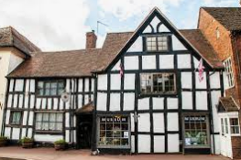
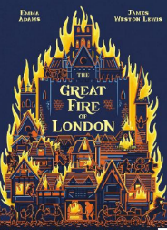
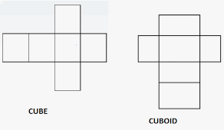

Developing Knowledge and Skills
Knowledge: |  | Working Towards | Within | Securely Within | Above
 | - To discuss and explore the architect Norman Foster
 | - To understand how Norman Foster helped develop and shape modern day architecture by designing The Gherkin
Design: |  | Working Towards | Within | Securely Within | Above
 | - To plan and sketch simple ideas for a three-dimensional Tudor House
 | - To select a range of appropriate materials to represent a Tudor House
 | - To design a purposeful house and communicate ideas through talking and simple drawings
 | - To discuss and use mathematical knowledge of nets of cubes and cuboids
Make: |  | Working Towards | Within | Securely Within | Above
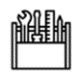   | - To select and use a range of tools and equipment to cut, shape and join a structure
 | - To select and use a range of materials to make a purposeful house
 | - To know how to make a freestanding three-dimensional structure stronger, stiffer and more stable
Evaluate: |  | Working Towards | Within | Securely Within | Above
 | - To explore and evaluate the design and make process through discussions
 | - To make suggestions for future improvements
The best bit about my Tudor House was_______________________________________________________________
_______________________________________________________________________________________________
My Tudor House would have been even better if ________________________________________________________
________________________________________________________________________________________________
Highlights: _______________________________________________________________________________________
________________________________________________________________________________________________



