

DT – Moving Easter Cards (Year 1)

Outcome: To create an Easter card using a slider or lever mechanism.

Ideas and inspiration:

RE – Easter

Completed Moving Easter Card

Slider Mechanism Lever Mechanism

Vocabulary:

- design
- make
- evaluate
- functional
- mechanism
- slider
- lever
- cut
- shape

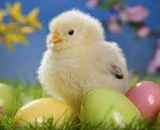

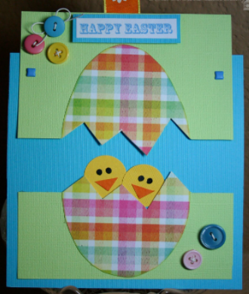
Developing Knowledge and Skills
Design: |  | Working Towards | Within | Securely Within | Above
 | - To plan and sketch simple ideas for a moving Easter card
 | - To design a functional Easter card and communicate ideas through talking and simple drawings
 | - To experiment using sliders and levers
Make: |  | Working Towards | Within | Securely Within | Above
   | - To select and use a range of tools and equipment to cut, shape and make a mechanism
 | - To select and use a range of materials to make a mechanism
Evaluate: |  | Working Towards | Within | Securely Within | Above
 | - To test the moving mechanism
 | - To explore and evaluate the design and make process through discussions
 | - To make suggestions for future improvements
The best bit about my card was______________________________________________________________________
________________________________________________________________________________________________
My card would have been even better if _______________________________________________________________
_________________________________________________________________________________________________
Highlights: _______________________________________________________________________________________
________________________________________________________________________________________________


