Prior Knowledge and Skills
Structures:
  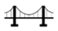 | - Successfully build a three-dimensional structure
 | - Accurately cut, shape and join the Iron Man to construct a strong, stable structure
 | - Use an electrical system to create light-up eyes
 | - Make a functional three-dimensional Iron Man with aesthetic qualities
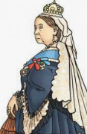
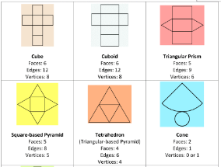

Ideas and inspiration:

History – The Victorians Maths – Nets

Completed 3D Victorian Bridge
Isambard Brunel – Engineer for the
Clifton Suspension Bridge

https://kids.kiddle.co/Isambard_Kingdom_Brunel
https://cliftonbridge.org.uk/

Vocabulary:

- design
- make
- evaluate
- functional
- structure
- purposeful
- nets
- cut
- shape
- join
- construct
- innovative
- three-dimensional
- components
- modify
- aesthetic
- civil engineer

DT – 3D Victorian Bridge (Year 6)
Outcome: To create a 3D model of a bridge.

Developing Knowledge and Skills
Knowledge: |  | Working Towards | Within | Securely Within | Above
 | - To discuss and explore the engineer Isambard Brunel
 | - To understand how Isambard Brunel helped develop and shape engineering and construction by designing the Clifton Suspension Bridge
Design: |  | Working Towards | Within | Securely Within | Above
 | - To create a design brief for the construction of a three-dimensional bridge, through peer discussions and research
 | - To plan, design and sketch innovative ideas for a purposeful bridge with annotated and pictorial representations
 | - To develop and apply mathematical knowledge of nets
Make: |  | Working Towards | Within | Securely Within | Above
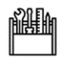 | - To select the appropriate shapes, materials and components to build a three-dimensional structure
 | - To accurately cut, shape and join the bridge to construct a strong, stable structure
 | - To make a purposeful three-dimensional bridge with aesthetic qualities
Evaluate: |  | Working Towards | Within | Securely Within | Above
 | - To continually evaluate and modify the product to match the initial design
 | - To evaluate the positive stages of the design and make process
 | - To evaluate the challenges of the design and make process
 | - To make suggestions for future improvements
The best bit about my bridge was___________________________________________________________________
_______________________________________________________________________________________________
My bridge would have been even better if ____________________________________________________________
________________________________________________________________________________________________
Highlights: _______________________________________________________________________________________
________________________________________________________________________________________________


