

DT – Shackleton’s Protective Pouch (Year 5)

Outcome: To sew a protective pouch for an Antarctic explorer.

Prior Knowledge and Skills
Textiles:
 | - Discuss and explore the jeweller Harry Winston
 | - Design and develop an appealing and functional stone age piece of jewellery with annotated drawings
 | - Make a functional stone age piece of jewellery with aesthetic qualities
Vocabulary:

- design
- make
- evaluate
- functional
- purposeful
- innovative
- textiles
- needle
- eye
- thread
- knot
- fabric
- blanket stitch
- running stitch

Ideas and inspiration:
Completed protective pouch example
English - Shackleton’s Journey

Running stitch
https://hopeandhart.com/2019/03/14/how-do-you-sew-running-stitch/

Blanket stitch
https://www.google.com/search?q=blanket+stitch+step+by+step&rlz=1C1GCEB_enGB967GB967&oq=blanket+stitch+&aqs=chrome.5.69i57j0i512l5j69i60l2.6803j0j4&sourceid=chrome&ie=UTF-8#kpvalbx=_xdakYeOAJ-aXxc8PguS56A819

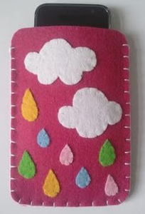
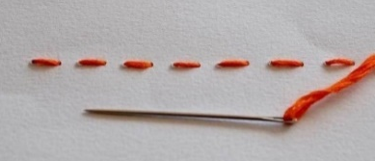
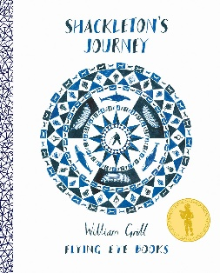

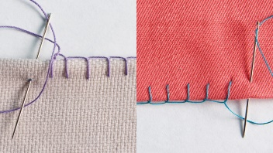

Developing Knowledge and Skills
Design: |  | Working Towards | Within | Securely Within | Above
 | - To plan and sketch innovative ideas for a protective pouch
 | - To design and develop a purposeful and functional protective pouch with explanations and annotated diagrams
 | - To experiment using a running and blanket stitch
Make: |  | Working Towards | Within | Securely Within | Above
 | - To accurately design and cut out a template pattern piece
 | - To sew with accuracy and control
 | - To make a functional protective pouch with aesthetic qualities
Evaluate: |  | Working Towards | Within | Securely Within | Above
 | - To consider the views of others to make improvements
 | - To evaluate the positive stages of the design and make process
 | - To evaluate the challenges of the design and make process
 | - To make suggestions for future improvements
The best bit about my pouch was____________________________________________________________________
_______________________________________________________________________________________________
My pouch would have been even better if _____________________________________________________________
________________________________________________________________________________________________
Highlights: _______________________________________________________________________________________
________________________________________________________________________________________________

