Prior Knowledge and Skills
Structures:
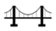 | - Use paper-mache to build a three-dimensional structure
 | - Accurately shape and mould the volcano to construct a strong, stable structure
 | - Make a functional three-dimensional volcano with aesthetic qualities


DT – 3D Iron Man (Year 4)
Outcome: To create a 3D Iron Man with an electrical system.

Vocabulary:

- design
- make
- evaluate
- functional
- structure
- purposeful
- nets
- cube
- cuboid
- cut
- shape
- join
- three-dimensional
- electrical system
- construct
- aesthetic

Ideas and inspiration:

English – The Iron Man Maths – Nets
Completed Iron Man with
light up eyes

Science – Electricity

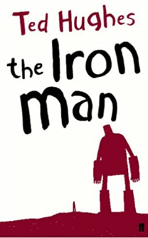
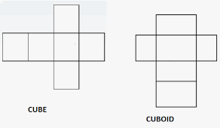
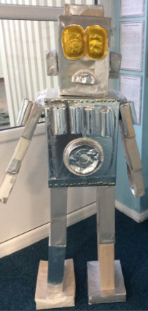
Developing Knowledge and Skills
Design: |  | Working Towards | Within | Securely Within | Above
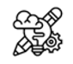 | - To plan and sketch realistic ideas for a three-dimensional Iron Man
 | - To design and develop a purposeful and functional Iron Man with explanations and annotated drawings
 | - To discuss and use mathematical knowledge of nets of cubes and cuboids
 | - To understand and explain electrical systems linked to science
Make: |  | Working Towards | Within | Securely Within | Above
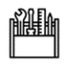   | - To successfully build a three-dimensional structure
 | - To accurately cut, shape and join the Iron Man to construct a strong, stable structure
 | - To use an electrical system to create light-up eyes
 | - To make a functional three-dimensional Iron Man with aesthetic qualities
Evaluate: |  | Working Towards | Within | Securely Within | Above
 | - To test the electrical system
 | - To evaluate the positive stages of the design and make process
 | - To evaluate the challenges of the design and make process
 | - To make suggestions for future improvements
The best bit about my Iron Man was__________________________________________________________________
_______________________________________________________________________________________________
My Iron Man would have been even better if ___________________________________________________________
________________________________________________________________________________________________
Highlights: _______________________________________________________________________________________
________________________________________________________________________________________________



