Prior Knowledge and Skills
Structures:
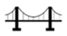 | - Select and use a range of tools and equipment to cut, shape and join a structure
 | - Select and use a range of materials to make a purposeful house
 | - Know how to make a freestanding three-dimensional structure stronger, stiffer and more stable


DT – 3D Volcano (Year 3)
Outcome: To create a 3D model volcano.

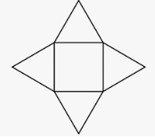
Ideas and inspiration:

Geography – Science – Forces Maths – Nets
Volcanos

Completed 3D model volcano

Exploding lava

https://www.thesprucecrafts.com/paper-mache-volcano-1253091

Vocabulary:

- design
- make
- evaluate
- functional
- purposeful
- construct
- nets
- pyramid
- shape
- mould
- structure
- three-dimensional
- chemical reaction
- aesthetic
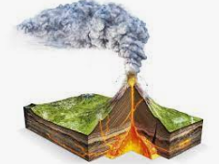
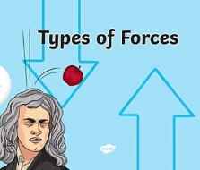

Developing Knowledge and Skills
Design: |  | Working Towards | Within | Securely Within | Above
 | - To plan and sketch realistic ideas for a functional, exploding three-dimensional volcano
 | - To design and develop a lifelike volcano with annotated drawings and diagrams
 | - To discuss and use mathematical knowledge of nets of pyramids
 | - To discuss the scientific chemical reaction and the forces used to make the explosion
Make: |  | Working Towards | Within | Securely Within | Above
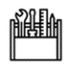 | - To successfully use paper-mache to build a three-dimensional structure
 | - To accurately shape and mould the volcano to construct a strong, stable structure
 | - To make a functional three-dimensional volcano with aesthetic qualities
Evaluate: |  | Working Towards | Within | Securely Within | Above
 | - To test the exploding chemical reaction
 | - To evaluate the positive stages of the design and make process
 | - To evaluate the challenges of the design and make process
 | - To make suggestions for future improvements
The best bit about my volcano was___________________________________________________________________
_______________________________________________________________________________________________
My volcano would have been even better if ____________________________________________________________
________________________________________________________________________________________________
Highlights: _______________________________________________________________________________________
________________________________________________________________________________________________


