

Art – Costa Rican Dot Work (Year 2)

Outcome: To take inspiration from Tingatinga dot work to paint a native animal from Costa Rica.

Prior Knowledge and Skills
Printing:
 | - Explore printing simple pictures with a range of materials
 | - Develop repeating patterns by using a variety of objects
 | - Investigate colour and hand printing
 | - Use equipment correctly to produce a clean printed image
 | - Show accuracy and care when printing
Vocabulary:
- design
- drawing
- proportion
- colour
- printing
- patterns
- texture
- mix
- tones
- lighter
- darker
- primary colours
- secondary colours
- dot work
- accuracy
- control

Ideas and inspiration:
Costa Rican Animals
Geography – Costa Rica

Example Dot Work Printing

Leopard by Tingtinga
https://wibseyprimary.co.uk/wp-content/uploads/2020/05/TINGATINGA-ART-PPT.pdf

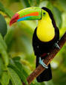
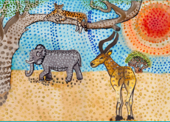
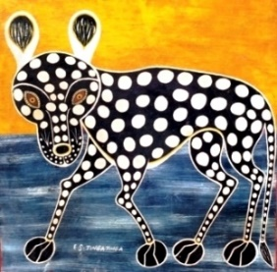
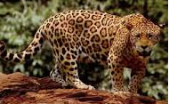

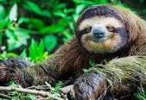

Developing Knowledge and Skills
Knowledge of culture, great art and artists: |  | Working Towards | Within | Securely Within | Above
 | - Discuss and explore the artist Edward Tingatinga
 | - Express thoughts and feelings about ‘Leopard’
Developing ideas: |  | Working Towards | Within | Securely Within | Above
 | - Research native animals of Costa Rica
 | - Plan and sketch native animals of Costa Rica
 | - Experiment using different size and types of printing tools
 | - Experiment with tones, texture, patterns and dot work
Printing: |  | Working Towards | Within | Securely Within | Above
 | - Choose the appropriate colours, shapes and textures to paint a native animal of Costa Rica
 | - Use equipment correctly to produce a clean printed image
 | - Show accuracy and control when printing
Highlights: _______________________________________________________________________________________

_______________________________________________________________________________________________

