

Art – Pirate Ship at Sea Collage (Year 1)

Outcome: To use a range of materials to create a ‘pirate ship at sea’ collage inspired by Alfred Wallis.

Prior Knowledge and Skills
Textiles and Collage:
 | - Experiment with form, texture and layers
 | - Use natural materials creatively to make a self-portrait
 | - Begin to show accuracy and care when collaging
Ideas and inspiration:

History – Pirates

The Blue Ship by Alfred Wallis
https://www.tate.org.uk/kids/explore/who-is/who-alfred-wallis

Example Collage
https://hannahsartclub.wordpress.com/2014/10/09/pirate-ships-in-stormy-seas-painted-paper-texture-collage-october-2014/

Vocabulary:
- design
- texture
- materials
- colour
- form
- size
- shape
- arrange
- layers
- equipment
- cut
- tear
- stick
- accuracy
- collage

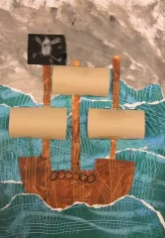
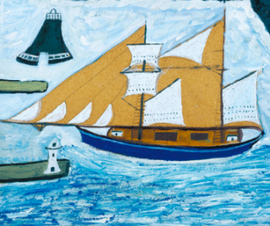
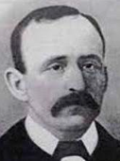

Developing Knowledge and Skills
Knowledge of culture, great art and artists: |  | Working Towards | Within | Securely Within | Above
 | - Discuss and explore the artist Alfred Wallis
 | - Express thoughts and feelings about ‘The Blue Ship’
Developing ideas: |  | Working Towards | Within | Securely Within | Above
 | - Look at and discuss the shapes of pirate ships and the sea
 | - Discuss and explore collaging
 | - Begin to identify different types and textures of fabric and materials for collage
Textiles and Collage: |  | Working Towards | Within | Securely Within | Above
 | - Select the appropriate colours, size, form and shapes
 | - Select the appropriate materials and equipment
 | - Use collage to make a pirate ship at sea, inspired by Alfred Wallis
 | - Show accuracy and care when being creative
Highlights: _______________________________________________________________________________________

_______________________________________________________________________________________________

