

Art – Graffiti Painting (Year 6)

Outcome: To paint in a graffiti style inspired by Banksy.

Prior Knowledge and Skills
Painting:
 | - Experiment with complimentary and contrasting colours for effect
 | - Understand how to create a background using a wash
 | - Experiment creating an ombré effect using watercolour paint
 | - Show accuracy, precision and control when being creative
Ideas and inspiration:

Geography – Argentina
Argentinian Street Art

Graffiti Writing

Example Graffiti

Vocabulary:
- design
- drawing
- sketch
- fonts
- styles
- techniques
- bold
- contrasting
- dripping
- pattern
- texture
- shape
- form
- space
- shades
- tones
- accuracy
- control

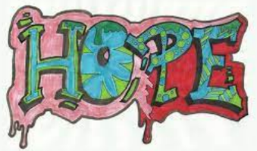
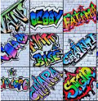
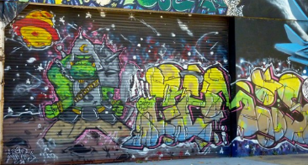

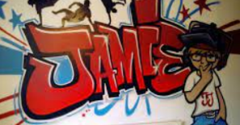
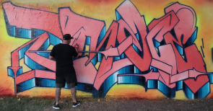
Developing Knowledge and Skills
Knowledge of culture, great art and artists: |  | Working Towards | Within | Securely Within | Above
 | - Discuss and explore Graffiti
 | - Express thoughts and feelings about Graffiti
Developing ideas: |  | Working Towards | Within | Securely Within | Above
 | - Research Argentinian Street art
 | - Plan and sketch various fonts, writing techniques and styles
 | - Experiment with bold, contrasting colours using acrylic paints
 | - Experiment with a dripping effect
 | - Experiment with pattern, texture, shape, form, and space
Painting: |  | Working Towards | Within | Securely Within | Above
 | - Develop an individual style of graffiti
 | - Mix colours, shades and tones with confidence building on previous knowledge
 | - Review and revisit sketchbook ideas to support the final piece and choose the appropriate painting techniques
 | - Show accuracy, control and confidence when painting
How was this learning similar to previous learning?_____________________________________________________
_______________________________________________________________________________________________
What worked well?_______________________________________________________________________________
_______________________________________________________________________________________________
Highlights: _______________________________________________________________________________________
_______________________________________________________________________________________________


