

Art – Maya Masks (Year 5)

Outcome: To create a Maya inspired mask.

Prior Knowledge and Skills:


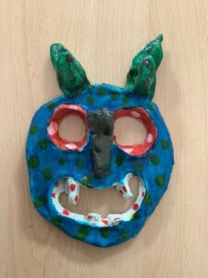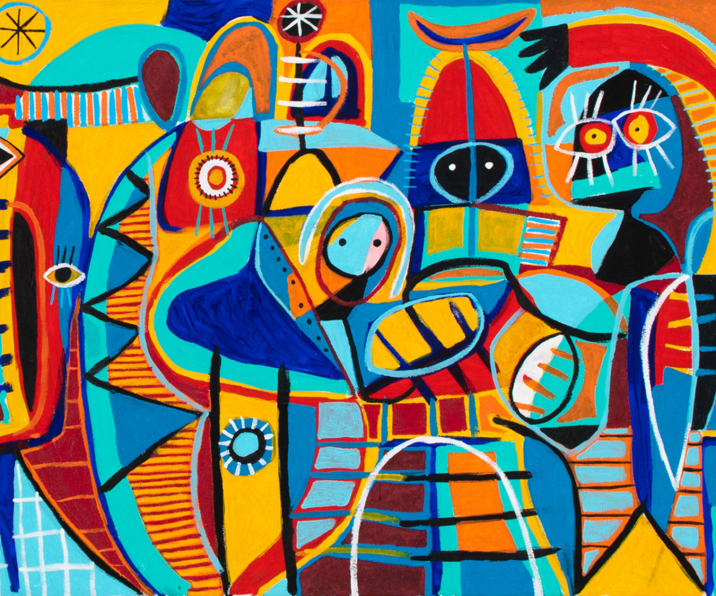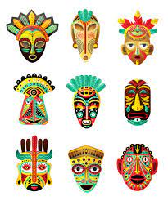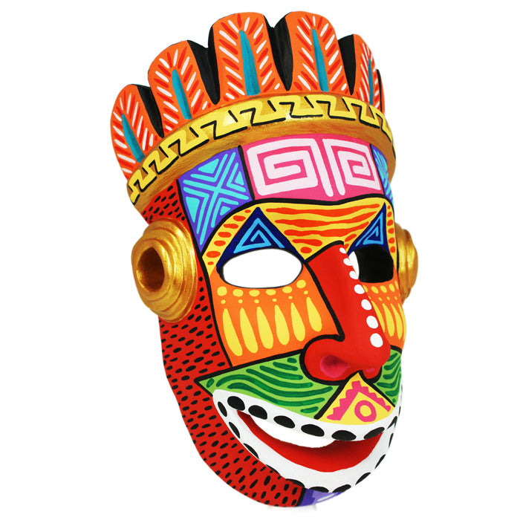

Vocabulary:

- design
- medium
- sketch
- sculpt
- mould
- attach
- score
- slip
- blend
- layer
- pattern
- texture
- embellishment
- line
- shape
- form
- bold
- precision
- accuracy
- control

Developing Knowledge and Skills
Knowledge: |  |  | Working Towards | Within | Securely Within | Above
 | - Discuss and explore the artist, Enrique Pichardo.
 | - Compare art from The Maya’s to modern art
Developing ideas: |  |  | Working Towards | Within | Securely Within | Above
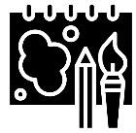 | - Plan and sketch ideas for a Maya mask.
 | - Take inspiration from Maya artwork.
 | - Experiment with different patterns, colours, and shapes.
Sculpture: |  |  | Working Towards | Within | Securely Within | Above
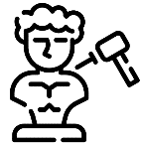 |  | - Carefully sculpt using paper mache.
 |  | - Select appropriate patterns and colours.
 |  | - Create a Maya inspired mask.
 |  | - Show accuracy, precision and control when sculpting.
How was this learning similar to previous learning?_____________________________________________________
_______________________________________________________________________________________________
What worked well?_______________________________________________________________________________
_______________________________________________________________________________________________
Highlights: _______________________________________________________________________________________
_______________________________________________________________________________________________

