

Art – Roman Mosaic (Year 4)

Outcome: To plan and create an individual Roman mosaic using tiles and grout.

Prior Knowledge and Skills
Collage:
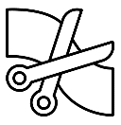 | - To select, gather and arrange materials in preparation for the final piece
 | - To select the appropriate colours, size, form and shapes
 | - To create a collage from imagination, experience and observation
 | - To show accuracy and control when being creative
Vocabulary:

- design
- medium
- pattern
- texture
- line
- shape
- form
- accuracy
- control
- tiles
- glue
- grout
- mosaic

Ideas and inspiration:
History – The Romans
Roman Mosaics

Ideas on Square Paper
Example Mosaic

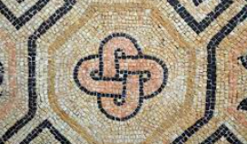
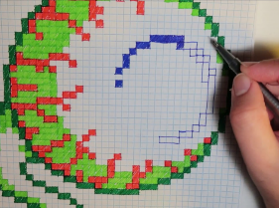
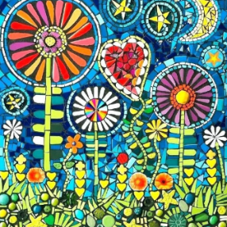
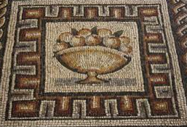

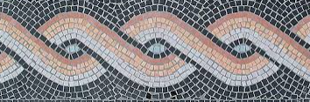
Developing Knowledge and Skills
Knowledge of culture, great art and artists: |  | Working Towards | Within | Securely Within | Above
 | - Discuss and explore art from The Romans
 | - Compare art from The Romans to modern art
Developing ideas: |  | Working Towards | Within | Securely Within | Above
 | - Take inspiration from The Romans
 | - Plan and sketch ideas for a mosaic
 | - Choose and plan appropriate colour palettes
 | - Discuss and experiment with mosaics and grout
Mosaic: |  | Working Towards | Within | Securely Within | Above
 | - Select, gather and arrange materials in preparation for the final piece
 | - Select the appropriate colours, pattern, texture, lines, shapes and form, to reflect The Romans
 | - Use glue and grout to secure the tiles
 | - Show accuracy, precision and control
Highlights: _______________________________________________________________________________________

_______________________________________________________________________________________________

