

Art – Egyptian Soap Sculpture (Year 3)

Outcome: To create an Egyptian soap sculpture.

Prior Knowledge and Skills
Sculpture:
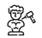 | - Discuss and experiment with clay sticking and moulding techniques
 | - Use the score, slip and blend techniques to sculpt and mould the clay correctly
 | - Show accuracy and control when sculpting
Ideas and inspiration:
Egyptian Art
History – The Egyptians

Egyptian Hieroglyphics

Example Soap Sculptures

Vocabulary:

- sculpture
- mould
- techniques
- patterns
- depth
- strengths
- movements
- textures
- sculpt
- shapes
- precision
- accuracy
- control

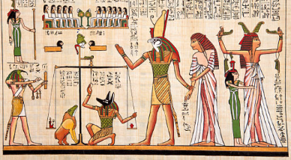
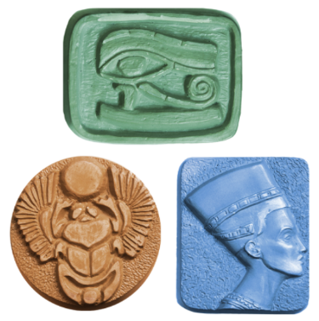
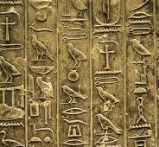

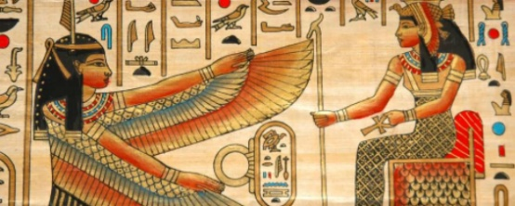

Developing Knowledge and Skills
Knowledge of culture, great art and artists: |  | Working Towards | Within | Securely Within | Above
 | - Discuss and explore art from The Egyptians
 | - Compare art from The Egyptians to modern art
Developing ideas: |  | Working Towards | Within | Securely Within | Above
 | - Take inspiration from Egyptian hieroglyphics
 | - Discuss and experiment with soap and moulding tools
 | - Experiment with different patterns, depths, strengths and movements to create a variety of textures
 | - Plan and sketch ideas for an Egyptian soap sculpture
Sculpture: |  | Working Towards | Within | Securely Within | Above
 | - Carefully and safely sculpt the soap
 | - Select appropriate textures, patterns and shapes
 | - Create an Egyptian soap sculpture
 | - Show accuracy, precision and control when sculpting
What worked well?_______________________________________________________________________________
_______________________________________________________________________________________________

What could I have done better?______________________________________________________________________
_______________________________________________________________________________________________

