

Art – Van Gogh Inspired Sunflowers (Year 1)

Outcome: To recreate Vincent Van Gogh’s Sunflowers painting.

Prior Knowledge and Skills:
 | - Experiment with primary colours and mixing
 | - Experiment using different size and types of brushes
 | - Choose the appropriate colours, brush strokes and textures to paint a self-portrait/still life

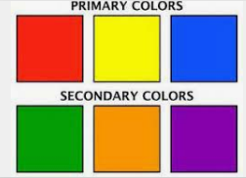
Vocabulary:

- design
- still life
- drawing
- sketch
- line
- proportion
- painting
- colour
- texture
- mix
- colour wheel
- primary colours
- secondary colours
- warm colours
- cool colours
- accuracy
Ideas and inspiration:
Artist Vincent Van Gogh Van Gogh’s Sunflowers
Science – Plants
Primary and secondary colours

https://www.youtube.com/watch?v=qv8TANh8djI
Examples of painted sunflowers
Colour mixing

Brush strokes

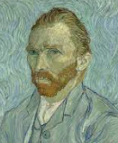
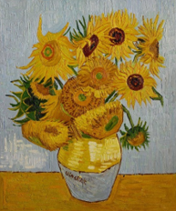

Developing Knowledge and Skills
Knowledge: |  |  | Working Towards | Within | Securely Within | Above
 | - Discuss and explore the artist Vincent Van Gogh
 | - Express thoughts and feelings about ‘Sunflowers’
Developing ideas: |  |  | Working Towards | Within | Securely Within | Above
 | - Practise drawing features of plants using sight and printed pictures
 | - Plan and sketch a still life
 | - Experiment with primary colours and mixing
 | - Experiment using different size and types of brushes
Painting: |  |  | Working Towards | Within | Securely Within | Above
 |  | - Choose the appropriate colours, brush strokes and textures to paint a self-portrait/still life
 |  | - Show accuracy and care when painting
My favourite part of learning was____________________________________________________________________

____________________________________________________________________________________________
Highlights: ___________________________________________________________________________________

____________________________________________________________________________________________



