

Art – 3D Clay Viking Dragon Eye (Year 5)

Outcome: To experiment with pattern, line, texture and detail to create a Viking dragon eye out of clay.

Prior Knowledge and Skills:
 | - Experiment with clay sticking and moulding techniques
 | - Select the appropriate colours, pattern, texture, lines, shapes and form, to reflect The Greeks
 | - Use the score, slip and blend techniques to sculpt and mould the clay correctly
Ideas and inspiration:

History – The Vikings

Sketch book ideas

Clay techniques

https://www.youtube.com/watch?v=kdtM_G90rhA

Example dragon eyes

Vocabulary:

- design
- medium
- sketch
- clay
- sculpt
- mould
- attach
- score
- slip
- blend
- layer
- pattern
- texture
- embellishment
- line
- shape
- form
- bold
- precision
- accuracy
- control

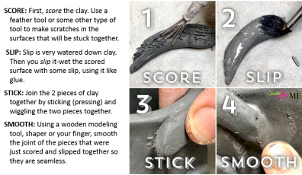
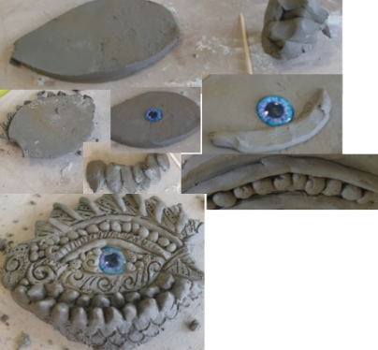

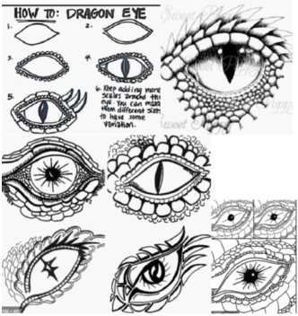

Developing Knowledge and Skills
Knowledge: |  |  | Working Towards | Within | Securely Within | Above
 | - Discuss and explore art from The Vikings
 | - Compare art from The Vikings to modern art
Developing ideas: |  |  | Working Towards | Within | Securely Within | Above
 | - Take inspiration from The Vikings
 | - Discuss and experiment with clay sticking and moulding techniques
 | - Plan, design and select ideas with annotated and pictorial representations
Sculpture: |  |  | Working Towards | Within | Securely Within | Above
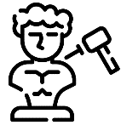 |  | - Show increasing confidence to carve and mould the clay
 |  | - Select appropriate textures, patterns and shapes
 |  | - Add paint and embellishment
 |  | - Create a dragon’s eye inspired by The Vikings
 |  | - Show accuracy, precision and control when sculpting
How was this learning similar to previous learning?_____________________________________________________
_______________________________________________________________________________________________
What worked well?_______________________________________________________________________________
_______________________________________________________________________________________________
Highlights: _______________________________________________________________________________________
_______________________________________________________________________________________________



