

Art – Katsushika Hokusai Inspired Waterfall (Year 4)

Outcome: To take inspiration from Hokusai and create a piece of art that experiments with texture.
Prior Knowledge and Skills:
 | - Select the most appropriate colours and mediums
 | - Use a range of textures, tones, shades, shapes and lines
 | - Use mixed media to make a selection of Greek pots
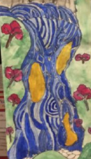
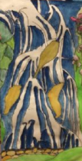
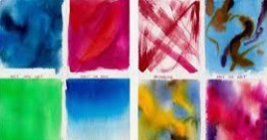
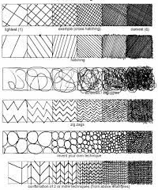
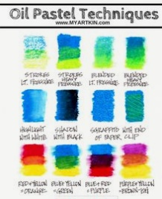
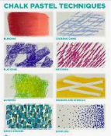
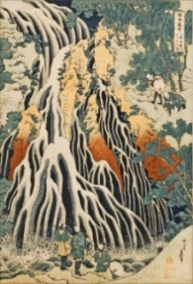
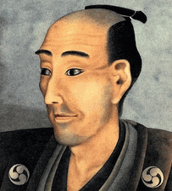
Ideas and inspiration:
Artist Katsushika Hokusai Hokusai’s Waterfalls
Geography – The Water Cycle
Pencils Watercolours

https://kids.kiddle.co/Katsushika_Hokusai

Oil Pastels Chalk Pastels Example waterfalls

Examples of different textures in art include: brushstrokes, colours, variety of materials
https://www.twinkl.co.uk/teaching-wiki/texture-in-art#:~:text=Texture%20in%20art%20concerns%20the,feeling'%20the%20piece%20gives%20off.

Vocabulary:

- design
- mixed media
- oil pastel resist
- grades
- tones
- shades
- complimentary
- contrasting
- mediums
- texture
- shapes
- lines
- accuracy
- control

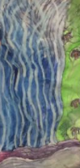
Developing Knowledge and Skills
Knowledge: |  |  | Working Towards | Within | Securely Within | Above
 | - Discuss and explore the artist Katsushika Hokusai
 | - Express thoughts and feelings about ‘Waterfalls’
Developing ideas: |  |  | Working Towards | Within | Securely Within | Above
 | - Experiment with oil pastels and watercolours to make an oil pastel resist
 | - Experiment with different grades of pencil to suggest tone
 | - Experiment with complimentary and contrasting colours for effect
 | - Plan, design and sketch ideas for a variety of waterfalls
Mixed Media: |  |  | Working Towards | Within | Securely Within | Above
 |  | - Select the most appropriate colours and mediums
 |  | - Use a range of textures, tones, shades, shapes and lines
 |  | - Use mixed media to make a waterfall scene inspired by Katsushika Hokusai
 |  | - Show accuracy and control when being creative
How was this learning similar to previous learning?_____________________________________________________
_______________________________________________________________________________________________
What worked well?_______________________________________________________________________________
_______________________________________________________________________________________________
Highlights: _______________________________________________________________________________________
_______________________________________________________________________________________________

