


Art – Digital Cave Paintings (Year 3)

Outcome: To create a digital Stone Age repeating pattern.

Prior Knowledge and Skills:
 | - Experiment with tracing paper to repeat the pattern.
 | - Experiment with texture, shape, form and space
 | - Show accuracy and control when being creative

Vocabulary:

- portrait
- design
- composition
- digital
- programme
- proportion
- repeating
- texture
- pattern
- tonal contrast
- monochrome
- edit
Ideas and inspiration:

History – The Stone Age Use: Microsoft Paint

https://www.youtube.com/watch?v=hlnodEYZ71w

https://www.wikihow.com/Use-Microsoft-Paint-in-Windows

Stone Age cave paintings

Example digital repeating cave pattern

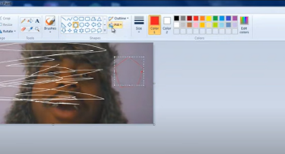
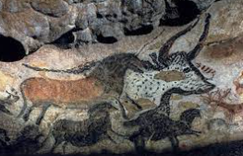

Developing Knowledge and Skills
Knowledge: |  | Working Towards | Within | Securely Within | Above
 | - Discuss and explore art from The Stone Age
 | - Compare art from The Stone Age to modern art
Developing ideas: |  | Working Towards | Within | Securely Within | Above
 | - Plan and sketch realistic ideas for a Stone Age cave painting with annotated drawings and diagrams
 | - Experiment using a simple computer paint programme
Digital: |  | Working Towards | Within | Securely Within | Above
 | - Create a Stone Age cave painting using a simple computer paint programme
 | - Experiment creating a repeating pattern using the digital Stone Age cave design
 | - Edit and finalise the digital artwork
How did my computer skills help me with my art?_______________________________________________________

_______________________________________________________________________________________________
Can I use these skills in other areas of my learning?_____________________________________________________

_______________________________________________________________________________________________
Highlights: _______________________________________________________________________________________

_______________________________________________________________________________________________



