

Art – Georgia O’Keeffe Inspired Plant Observation (Year 2)

Outcome: To use a choice of mixed media to produce a flower inspired by Georgia O’Keeffe.

Prior Knowledge and Skills:
 | - Experiment with a variety of mediums
 | - Select the most appropriate colours and mediums
 | - Use mixed media to make a selection of abstract seasonal trees, inspired by Kandinsky
Ideas and inspiration:
Artist Georgia O’Keeffe O’Keeffe’s Oriental Poppies
Science – Plants

Pencils Watercolours

https://www.tate.org.uk/kids/explore/who-is/who-georgia-okeeffe
Oil Pastels Chalk Pastels Examples of mixed media plants

Vocabulary:

- design
- mixed media
- observe
- mediums
- bold
- striking
- colour palette
- texture
- rubbings
- surface
- patterns
- shapes
- lines
- accuracy
- control

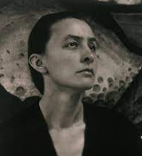
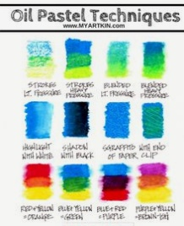
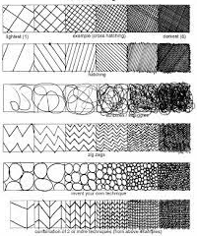
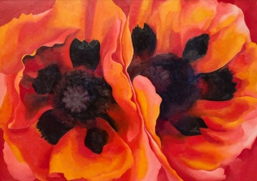
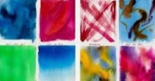

Developing Knowledge and Skills
Knowledge: |  |  | Working Towards | Within | Securely Within | Above
 | - Discuss and explore the artist Georgia O’Keeffe
 | - Express thoughts and feelings about ‘Oriental Poppies’
Developing ideas: |  |  | Working Towards | Within | Securely Within | Above
 | - Observe and sketch a variety of plants
 | - Experiment with a variety of mediums
 | - Discuss and experiment using a bold and striking colour palette
 | - Investigate texture, surface patterns and rubbings using natural materials
Mixed Media: |  |  | Working Towards | Within | Securely Within | Above
 |  | - Select the most appropriate colours and mediums
 |  | - Use a range of textures, shapes and lines
 |  | - Use mixed media to create a flower inspired by Georgia O’Keeffe
 |  | - Show accuracy and control when being creative
Highlights: ___________________________________________________________________________________

____________________________________________________________________________________________



