

Art – Great Fire of London Collage (Year 2)

Outcome: To produce a collage of Pudding Lane.

Prior Knowledge and Skills:
 | - Experiment with form, texture and layers
 | - Begin to show accuracy and care when collaging

Vocabulary:

- design
- texture
- colour
- craft
- attach
- arrange
- layers
- combination
- create
- form cut
- tear glue
- control
- accuracy
- collage
Ideas and inspiration:

History – The Great Fire of London

Collaging Example Pudding Lane Collage

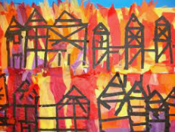
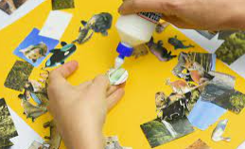

Developing Knowledge and Skills
Developing ideas: |  | Working Towards | Within | Securely Within | Above
 | - To discuss appropriate materials for a collage
 | - To experiment with a combination of materials by cutting, tearing and gluing
 | - To experiment with a variety of materials varying in texture
 | - To create a draft/plan a collage
Textiles and Collage: |  | Working Towards | Within | Securely Within | Above
 | - To select, gather and arrange materials in preparation for the final piece
 | - To select the appropriate colours, size, form and shapes
 | - To create a collage from imagination, experience and observation
 | - To show accuracy and control when being creative
My favourite part of my collage is____________________________________________________________________
________________________________________________________________________________________________
What could I have done better? ____________________________________________________________________
________________________________________________________________________________________________
Highlights________________________________________________________________________________________
________________________________________________________________________________________________

