

Art – Kandinsky Inspired Seasonal Trees (Year 1)

Outcome: To take inspiration from Kandinsky’s tree art to represent seasonal changes using mixed media.

Prior Knowledge and Skills:
 | - Experiment with primary colours and mixing
 | - Use different size and types of brushes
Ideas and inspiration:
Pencils Watercolours Oil Pastels Chalk Pastels

Artist Wassily Kandinsky

Example Tree
https://www.youtube.com/watch?v=qt89fWM9ex4
Kandinsky’s Squares in Concentric Circles

Vocabulary:

- design
- drawing
- mixed media
- sketch
- proportion
- colour wheel
- primary colours
- secondary colours
- warm colours
- cool colours
- concentric circles
- experiment
- accuracy
- medium
- abstract
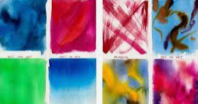
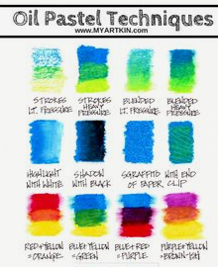
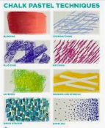
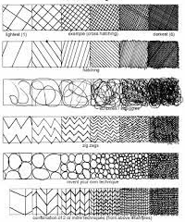

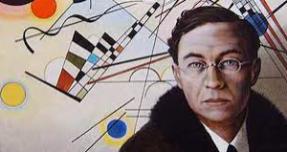

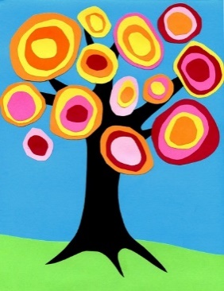

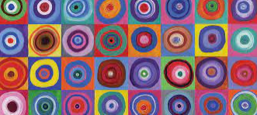
Developing Knowledge and Skills
Knowledge: |  |  | Working Towards | Within | Securely Within | Above
 | - To discuss and explore the artist Wassily Kandinsky
 | - To express thoughts and feelings about ‘Squares in Concentric Circles’
Developing ideas: |  |  | Working Towards | Within | Securely Within | Above
 | - To go on a seasonal walk identifying the colours of the leaves on the trees during each season
 | - To discuss appropriate colours for their abstract seasonal tree
 | - To practice drawing concentric circles within a square
 | - To experiment with a variety of mediums
Mixed Media: |  |  | Working Towards | Within | Securely Within | Above
 |  | - To select the most appropriate colours and mediums
 |  | - To use mixed media to make a selection of abstract seasonal trees, inspired by Kandinsky
 |  | - To show accuracy and care when being creative
How did I use the primary colours in my learning?_______________________________________________________
________________________________________________________________________________________________
Which media did I prefer to use? ____________________________________________________________________
________________________________________________________________________________________________
Highlights________________________________________________________________________________________
________________________________________________________________________________________________

