

Art – William Morris Pattern Experiment (Year 6)

Outcome: To use a viewfinder to create a detailed drawing in the style of William Morris.

Prior Knowledge and Skills:
 | - Explore different gradient pencils
 | - Explore a range of tones through cross-hatching, hatching and stippling
 | - Experiment with texture, shape, form and space
Ideas and inspiration:
Viewfinder
History – The Victorians

Morris’ Strawberry Thief

Example viewfinder pattern

Artist William Morris https://kids.kiddle.co/William_Morris

Vocabulary:
- design
- scale
- space
- medium
- sketch
- proportion
- pattern
- texture
- line
- shape
- composition
- form
- accuracy
- experiment
- viewfinder
- detail
- cross-hatching
- tonal
- stippling
- hatching
- control
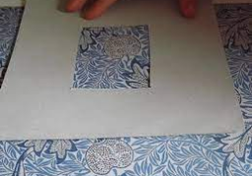
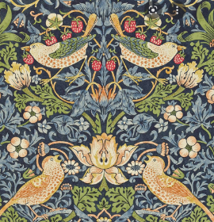
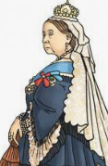


Developing Knowledge and Skills
Knowledge: |  |  | Working Towards | Within | Securely Wthin | Above
 | - To discuss and explore the artist William Morris
 | - To express thoughts and feelings about ‘Strawberry Thief’
Developing ideas: |  |  | Working Towards | Within | Securely Wthin | Above
 | - To experiment with sketching and copying patterns
 | - To plan, design and select ideas with annotated and pictorial representations
 | - To experiment with pattern, texture, line, shape, form, proportion and space
 | - To use a viewfinder to focus on detailed patterns
Mixed Media: |  |  | Working Towards | Within | Securely Wthin | Above
 |  | - To use a range of patterns, textures, line, shape and form
 |  | - To develop an awareness of composition and scale
 |  | - To review and revisit sketchbook ideas to support the final piece and choose the appropriate drawing techniques
 |  | - To draw with accuracy, control and to scale
 |  | - To reflect and compare the final piece with William Morris’ artwork
I am most proud of________________________________________________________________________________
________________________________________________________________________________________________
How can I apply this learning to other situations?________________________________________________________
________________________________________________________________________________________________
Highlights________________________________________________________________________________________
________________________________________________________________________________________________



