

Art – Paul Klee Inspired Landscape (Year 5)

Outcome: To create a tonal painting using oil pastel and watercolour in the style of Paul Klee.

Prior Knowledge and Skills:
 | - Experiment with black paint and oil pastels to make an oil pastel resist
 | - Experiment with complementary and contrasting colours for effect
Ideas and inspiration: https://www.youtube.com/watch?v=01hFGaAvaok
Watercolour resist
English – Shackleton’s Journey

Paul Klee’s Resting Ships

Example oil pastel landscape

Artist Paul Klee https://kids.kiddle.co/Paul_Klee

Vocabulary:

- design
- mixed media
- oil pastel resist
- wash
- tones
- tints
- light
- shade
- monochrome
- mood
- atmosphere
- abstract
- shapes
- lines
- accuracy
- precision
- control
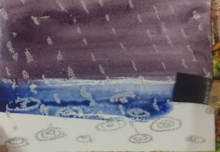
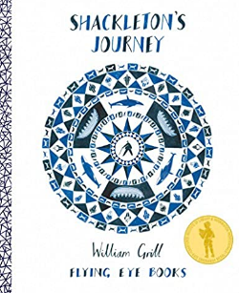
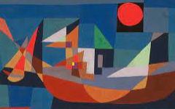

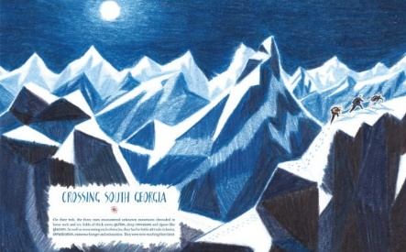
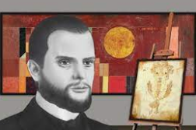
Developing Knowledge and Skills
Knowledge: |  |  | Working Towards | Within | Securely Wthin | Above
 | - To discuss and explore the artist Paul Klee
 | - To express thoughts and feelings about ‘Resting Ships’
Developing ideas: |  |  | Working Towards | Within | Securely Wthin | Above
 | - To experiment with oil pastels and watercolours to make an oil pastel resist
 | - To understand how to create a background using a wash
 | - To experiment using tones and tints, light and shade
 | - To consider the use of colour for mood and atmosphere
 | - To plan, design and select ideas with annotated and pictorial representations
Mixed Media: |  |  | Working Towards | Within | Securely Wthin | Above
 |  | - To use a monochrome colour palette
 |  | - To use a range of abstract shapes and lines
 |  | - To use mixed media to create an Antarctic landscape inspired by Paul Klee
 |  | - To show accuracy, precision and control when being creative
I used skills from Year 4 (Greek pots) by _______________________________________________________________
________________________________________________________________________________________________
How can I apply this learning to other situations?_______________________________________________________
________________________________________________________________________________________________
Highlights________________________________________________________________________________________
________________________________________________________________________________________________

