

Art – Oil Pastel Greek Pots (Year 4)

Outcome: To draw a Greek pot and use mixed media to replicate traditional Greek patterns.

Prior Knowledge and Skills:
 | - Select the most appropriate colours and mediums
 | - Use mixed media to make a selection of self-portraits
Vocabulary:

- design
- mixed media
- oil pastel resist
- grades
- tones
- shades
- complimentary
- contrasting
- mediums
- texture
- shapes
- lines
- accuracy
- control
Ideas and inspiration: https://www.youtube.com/watch?v=01hFGaAvaok
Watercolour resist

History – The Greeks

Greek pots

Example oil pastel Greek pots

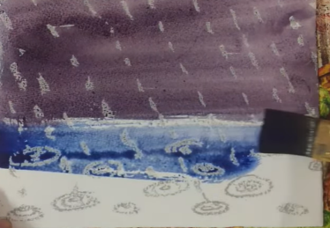

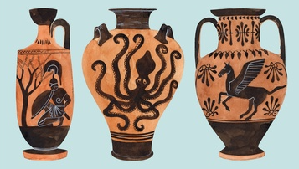

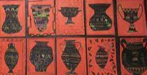

Developing Knowledge and Skills
Knowledge: |  |  | Working Towards | Within | Securely Wthin | Above
 | - To discuss and explore art from The Greeks
 | - To compare art from The Greeks to modern art
Developing ideas: |  |  | Working Towards | Within | Securely Wthin | Above
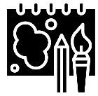 | - To experiment with black paint and oil pastels to make an oil pastel resist
 | - To experiment with complimentary and contrasting colours for effect
 | - To plan, design and sketch ideas for a variety of Greek pots
Mixed Media: |  |  | Working Towards | Within | Securely Wthin | Above
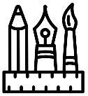 |  | - To select the most appropriate colours and mediums
 |  | - To use a range of textures, tones, shades, shapes and lines
 |  | - To use mixed media to make a selection of Greek pots
 |  | - To show accuracy and control when being creative
I used skills from Year 3 by__________________________________________________________________________
________________________________________________________________________________________________
How can I apply my learning to other situations?_______________________________________________________
________________________________________________________________________________________________
Highlights________________________________________________________________________________________
________________________________________________________________________________________________

