

Art – Observational Landscape Study (Year 3)

Outcome: To observe and sketch a natural landscape.

Prior Knowledge and Skills:
 | - Observe and sketching a variety of plants
 | - Use a range of textures, shapes and lines
Ideas and inspiration: Landscape proportion
History – The Stone Age

Shading techniques

Example landscape drawing

https://www.youtube.com/watch?v=-iaINVnw89Q

https://www.youtube.com/watch?v=-WR-FyUQc6I&t=182s

Vocabulary:

- observe
- observations
- draw
- sketch
- still life
- line
- shape
- size
- texture
- detail
- cross-hatching
- hatching
- tonal
- stippling
- proportion
- scale
- form
- space
- experiment
- accuracy
- control
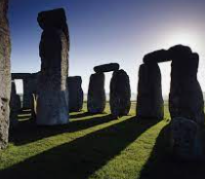
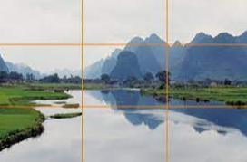
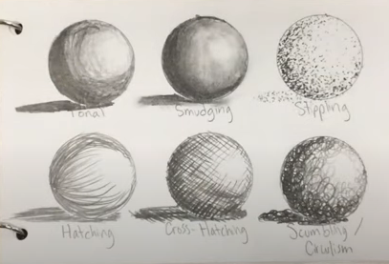

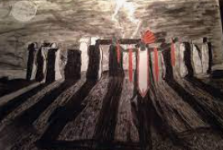

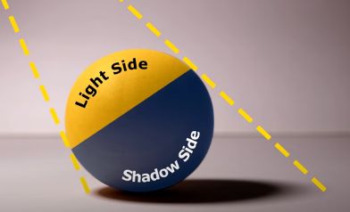

Developing Knowledge and Skills
Developing ideas: |  | Working Towards | Within | Securely Wthin | Above
 | - To experiment with sketching
 | - To explore different gradient pencils
 | - To explore different tones through cross-hatching, hatching and stippling
 | - To experiment with texture, shape, form and space
Drawing: |  | Working Towards | Within | Securely Wthin | Above
 | - To take inspiration from a natural landscape in the moment
 | - To record and sketch ideas from first hand observations as realistically and as true to life as possible
 | - To draw with accuracy, control and to scale
 | - To reflect on the sketch and discuss observational drawings
My favourite part of my drawing is___________________________________________________________________
________________________________________________________________________________________________
How can I apply my learning to other situations?_______________________________________________________
________________________________________________________________________________________________
Highlights________________________________________________________________________________________
________________________________________________________________________________________________

