

Art – Self-Portraits (Reception)

Outcome: To use natural materials to create a self-portrait.

Ideas and inspiration:

PSHE – Being me in my world

Examples of self-portraits made using natural materials

Vocabulary:

- portrait
- design
- texture
- natural
- sketch
- colour
- arrange
- sort
- layers
- join
- collage

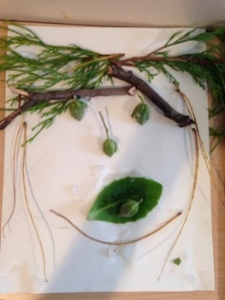
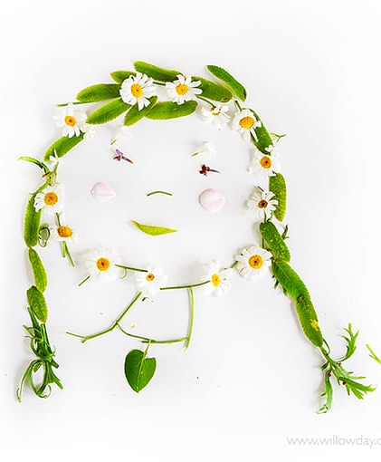
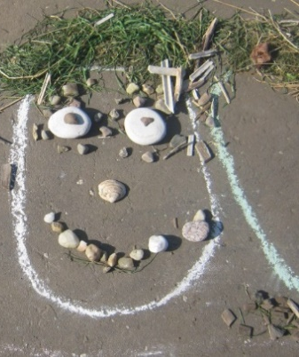

Developing Knowledge and Skills
Developing ideas: |  | Emerging | Expected
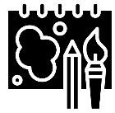 | - To investigate self-portraits made using natural materials
 | - To discuss appropriate natural materials
 | - To plan and sketch ideas for a self-portrait
 | - To experiment with form, texture and layers
Textiles and collage: |  | Emerging | Expected
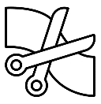 | - To gather natural materials
 | - To use natural materials creatively to make a self-portrait
 | - To begin to show accuracy and care when collaging
 | - To share and explain the final piece

