

Art – Self-Portraits (Year 6)

Outcome: To create a digital self-portrait.



Prior Knowledge and Skills:
 | - Understand the term self-portrait
 | - Create a plan
 | - Make a final piece

Ideas and inspiration:

PSHE – Being me in my world Digital Programme kleki Use: https://kleki.com/
Computing – Programming

Artist Roy Lichtenstein Example digital self-portrait

Girl with Hair Ribbon
(Pop Art)

Instructions: https://makeamarkstudios.com/how-to-draw-a-1-2-cartoon-digital-portrait/

https://www.tate.org.uk/kids/explore/who-is/who-roy-lichtenstein

Vocabulary:

- portrait
- design
- composition
- digital
- software
- tonal contrast
- proportion
- form
- layers
- silhouette
- texture
- accuracy
- control
- order
- edit
- format
- pop art
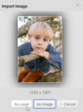

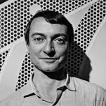
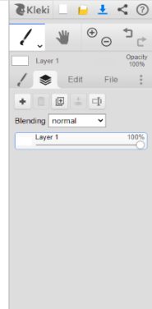
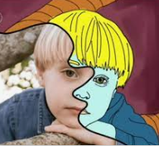

Developing Knowledge and Skills
Knowledge: |  | Working Towards | Within | Securely Wthin | Above
 | - To discuss and explore the artist Roy Lichtenstein
 | - To express thoughts and feelings about ‘Girl with Hair Ribbon’
Developing ideas: |  | Working Towards | Within | Securely Wthin | Above
 | - To plan, design and sketch innovative ideas for a digital self-portrait with annotated and pictorial representations
 | - To experiment using digital and editing software
Digital: |  | Working Towards | Within | Securely Wthin | Above
 | - To use a camera to take a photograph
 | - To use digital software to edit a photograph
 | - To use appropriate, line, shape, form, proportion, colour and space
 | - To experiment with layers and ordering
 | - To review and revisit sketchbook ideas to support the final piece
How did I build upon my prior knowledge and experience?________________________________________________
________________________________________________________________________________________________
What will I do differently next year? __________________________________________________________________
________________________________________________________________________________________________
Highlights________________________________________________________________________________________
________________________________________________________________________________________________



