

Art – Self-Portraits (Year 5)

Outcome: To create a self-portrait using ink.

Prior Knowledge and Skills:
 | - Understand the term self-portrait
 | - Create a plan
 | - Make a final piece
Ideas and inspiration: Facial features

PSHE – Being me in my world Viewfinder

Shading techniques

Example self-portrait

https://www.youtube.com/watch?v=-iaINVnw89Q

https://www.youtube.com/watch?v=-WR-FyUQc6I&t=182s

Vocabulary:

- portrait
- design
- medium
- sketch
- proportion
- pattern
- texture
- line
- shape
- space
- experiment
- form
- accuracy
- control
- photography
- viewfinder
- detail
- cross-hatching
- hatching
- tonal
- stippling
- scale

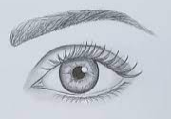
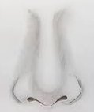
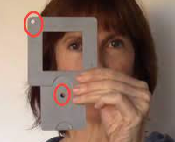
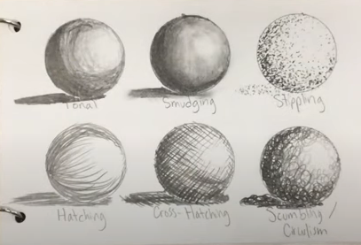
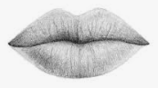

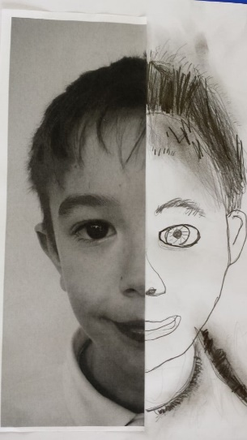

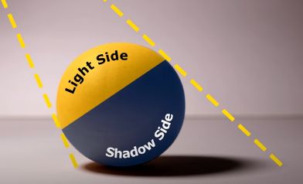

Developing Knowledge and Skills
Developing ideas: |  | Working Towards | Within | Securely Wthin | Above
 | - To plan, design and sketch ideas for a self-portrait with annotated and pictorial representations
 | - To experiment drawing different halves of the face
 | - To experiment with pattern, texture, line, shape, form, proportion and space
 | - To use a viewfinder to focus on detailed facial features
Drawing: |  | Working Towards | Within | Securely Wthin | Above
 | - To use a range of patterns, textures, lines, shapes, forms, proportion and space in a self-portrait
 | - To review and revisit sketchbook ideas to support the final piece and choose the appropriate techniques for facial features
 | - To draw with accuracy, control and to scale
How did I build upon my prior knowledge and experience?________________________________________________
________________________________________________________________________________________________
What will I do differently next year? __________________________________________________________________
________________________________________________________________________________________________
Highlights________________________________________________________________________________________
________________________________________________________________________________________________

