

Art – Self-Portraits (Year 4)

Outcome: To sculpt a self-portrait inspired by the Greeks.

Prior Knowledge and Skills:
 | - Understand the term self-portrait
 | - Create a plan
 | - Make a final piece
Vocabulary:

- portrait
- design
- bust
- medium
- three-dimensional
- sketch
- clay
- sculpt
- layer
- pattern
- mould
- score
- slip
- blend
- texture
- line
- shape
- form
- accuracy
- control

Ideas and inspiration:

PSHE – Being me in my world
History – The Greeks

Greek statues
Example self-portrait

Clay techniques

https://www.youtube.com/watch?v=kdtM_G90rhA

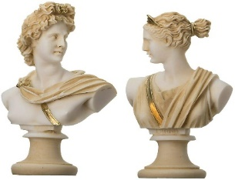

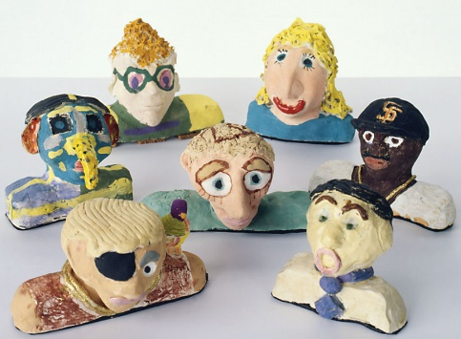

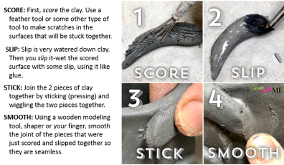

Developing Knowledge and Skills
Knowledge: |  |  | Working Towards | Within | Securely Wthin | Above
 | - To discuss and explore art from The Greeks
 | - To compare art from The Greeks to modern art
Developing ideas: |  |  | Working Towards | Within | Securely Wthin | Above
 | - To take inspiration from The Greeks
 | - To plan and sketch ideas for a three-dimensional clay self-portrait
 | - To choose and plan appropriate colour palettes
 | - To discuss and experiment with clay sticking and moulding techniques
Sculpture: |  |  | Working Towards | Within | Securely Wthin | Above
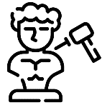 |  | - To select, gather and arrange materials in preparation for the final piece
 |  | - To select the appropriate colours, pattern, texture, lines, shapes and form, to reflect The Greeks
 |  | - To use the score, slip and blend techniques to sculpt and mould the clay correctly
 |  | - To show accuracy, precision and control when sculpting
How did I build upon my prior knowledge and experience?________________________________________________
________________________________________________________________________________________________
What will I do differently next year? __________________________________________________________________
________________________________________________________________________________________________
Highlights________________________________________________________________________________________
________________________________________________________________________________________________

