

Art – Self-Portraits (Year 3)

Outcome: To produce a self-portrait inspired by Andy Warhol.

Prior Knowledge and Skills:
 | - Understand the term self-portrait
 | - Create a plan
 | - Make a final piece
Vocabulary:

- portrait
- design
- mixed media
- pattern
- medium
- sketch
- pop art
- abstract
- layer
- proportion
- subject
- background
- control
- foreground
- colour palette
- bold
- striking
- experiment
- accuracy
Ideas and inspiration:
Pencils Watercolours Oil Pastels Chalk Pastels
PSHE – Being me in my world

Artist Andy Warhol

Example self-portrait
https://www.tate.org.uk/kids/explore/who-is/who-andy-warhol
Andy Warhol’s self-portrait
Marilyn Monroe (Pop Art)

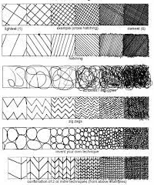
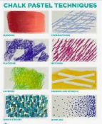
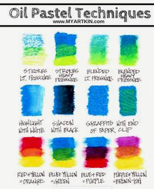
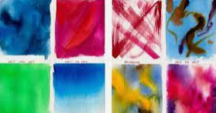
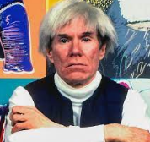

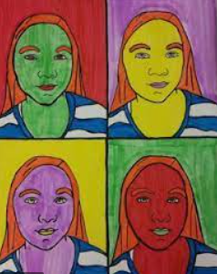
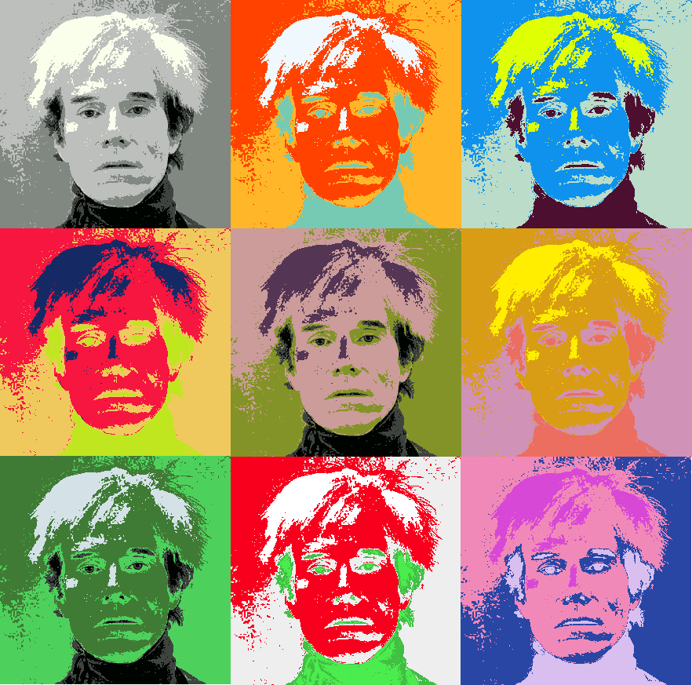
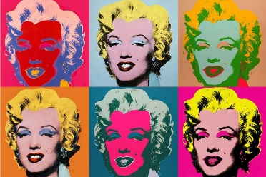
Developing Knowledge and Skills
Knowledge: |  |  | Working Towards | Within | Securely Wthin | Above
 | - To discuss and explore the artist Andy Warhol
 | - To express thoughts and feelings about ‘Marilyn Monroe’
Developing ideas: |  |  | Working Towards | Within | Securely Wthin | Above
 | - To investigate a range of Pop Art portraits
 | - To discuss and experiment using a bold and striking colour palette
 | - To plan and sketch ideas for a self-portrait
 | - To experiment with tracing paper to repeat the pattern
Mixed Media: |  |  | Working Towards | Within | Securely Wthin | Above
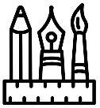 |  | - To select the most appropriate colours and mediums
 |  | - To use mixed media to make a selection of self-portraits
 |  | - To use a range of contrasting colours for maximum impact
 |  | - To show accuracy and control when being creative
How was my self-portrait similar to the self-portrait I did in Year 2?_________________________________________
________________________________________________________________________________________________
What will I do differently next year? __________________________________________________________________
________________________________________________________________________________________________
Highlights________________________________________________________________________________________
________________________________________________________________________________________________

