

Art – Self-Portraits (Year 2)

Outcome: To sculpt a self-portrait inspired by Pablo Picasso.

Prior Knowledge and Skills:
 | - Understand the term self-portrait
 | - Create a plan
 | - Make a final piece

Ideas and inspiration:

PSHE – Being me in my world

Artist Pablo Picasso https://www.tate.org.uk/kids/explore/who-is/who-pablo-picasso

Clay Portrait Painted Clay Portrait

The Weeping Woman (Cubism)

https://www.youtube.com/watch?v=kdtM_G90rhA

Vocabulary:

- portrait
- design
- cubism
- medium
- sketch
- clay
- sculpt
- mould
- score
- slip
- blend
- layer
- pattern
- texture

line

shape

form

bold

striking

accuracy

control

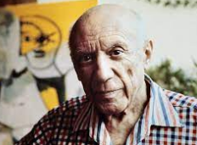
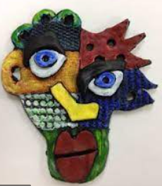
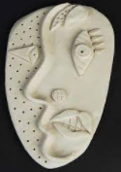

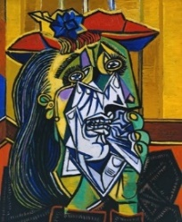

Developing Knowledge and Skills
Knowledge: |  | Working Towards | Within | Securely Within | Above
 | - Discuss and explore the artist Pablo Picasso
 | - Express thoughts and feelings about ‘The Weeping Woman’
Developing ideas: |  | Working Towards | Within | Securely  Within | Above
 | - Investigate self-portraits made from clay
 | - Take inspiration from Cubism
 | - Discuss and experiment with clay sticking and moulding techniques
 | - Plan and sketch ideas for a self-portrait
Sculpture: |  | Working Towards | Within | Securely  Within | Above
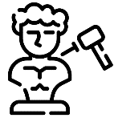 | - Use the score, slip and blend techniques to sculpt and mould the clay correctly
 | - Select the appropriate pattern, texture, line, shape and form to reflect Cubism
 | - Paint using bold and striking colours for maximum effect
 | - Show accuracy and control when sculpting
How was my self-portrait similar to the self-portrait I did in Year 1?_________________________________________
________________________________________________________________________________________________
________________________________________________________________________________________________
Highlights________________________________________________________________________________________
________________________________________________________________________________________________

