

Art – Self-Portraits (Year 1)

Outcome: To paint a self-portrait using colour mixing.

Prior learning:
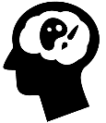 | - Understand the term self-portrait
 | - Create a plan
 | - Make a final piece

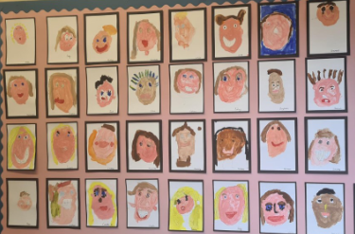
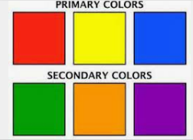
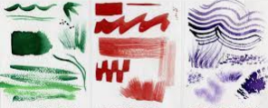
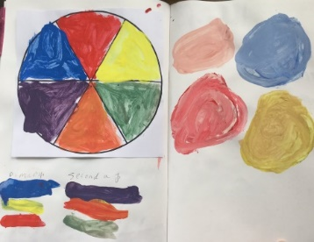
Vocabulary:

- design
- portrait
- still life
- drawing
- sketch
- line
- proportion
- painting
- colour
- texture
- mix
- colour wheel
- primary colours
- secondary colours
- warm colours
- cool colours
- accuracy
Ideas and inspiration:

PSHE – Being me in my world
Brush strokes
Primary and secondary colours

Examples of painted self-portraits on display

Colour mixing


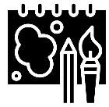
Developing Knowledge and Skills
Developing ideas: |  | Working Towards | Within | Securely Within | Above
 | - To practise drawing features of faces/plants using mirrors/sight and printed pictures
 | - To plan and sketch a self-portrait/still life
 | - To experiment with primary colours and mixing
 | - To experiment using different size and types of brushes
Painting: |  | Working Towards | Within | Securely Within | Above
 | - To choose the appropriate colours, brush strokes and textures to paint a self-portrait/still life
 | - To show accuracy and care when painting
How was my self-portrait similar to the self-portrait I did in Reception?______________________________________
________________________________________________________________________________________________
What will I do differently next year? __________________________________________________________________
________________________________________________________________________________________________
Highlights________________________________________________________________________________________
________________________________________________________________________________________________

