

Level 3

Music- Piano skills
Outcome: To develop proficiency in reading musical notation, expanding knowledge of semibreves, crotchets, and quaver rhythms, as well as melodic notation in the treble and bass clefs.

Prior skills:
Prior skills from Level 2
- Understand the musical alphabet, using time values and reading music from the treble clef
- Perform melodies using a new hand position on the keyboard
- Using two finger chords to play along to popular songs

- Treble and bass clef
- Major and minor chord
- Two/three finger chords in root position
- Melodic and rhythmic notation
- Dynamics, technique, rhythmic accuracy, melodic accuracy
- Melodies
- Rhythms
Vocabulary:

Ideas and inspiration:
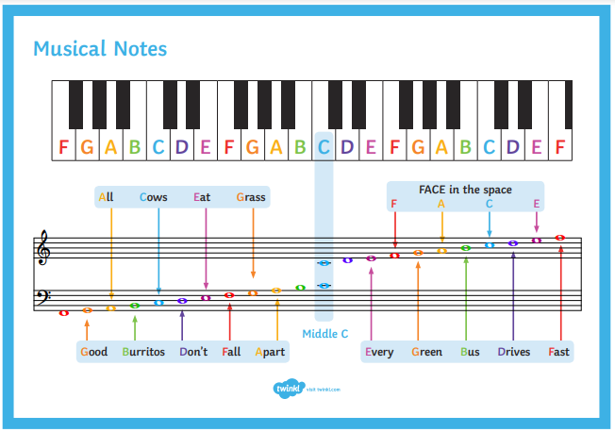

Developing Knowledge:
Knowledge |  | Working Towards | Within | Expected | Above
 | - Understanding the notes of the piano, including reading treble and bass clef  - Differentiating between major and minor chords  - Knowledge of constructing two/three finger chords in root position
Developing skills:
Skills |  | Working Towards | Within | Expected | Above
  Musicianship and performance | - Performing songs using melodic and rhythmic notation in both treble and bass clef  - Developing piano technique and proficiency in playing melodies and rhythm  - Performing with both hands simultaneously, incorporating crotchet, quaver, and semibreve rhythms  - Singing and playing chords simultaneously using pop songs from the vocal course
  Composition | - Applying knowledge of chords and individual melody notes to perform a small piece of music  - Constructing and performing a pop song using a range of rhythms, melodies, and chords in both hands
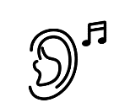  Listening | - Developing ear training skills to identify the difference between major and minor chord by ear  - Evaluating peer performances, discussing dynamics, technique, rhythmic accuracy, and melodic accuracy
Evaluate |  | Working Towards | Within | Expected | Above
 | - Engaging in class performances and evaluating peer performances  - Providing feedback on dynamics, technique, rhythmic accuracy, and melodic accuracy
Highlights: ___________________________________________________________________________________

_____________________________________________________________________________________________

