

Level 2

Music- Boomwhackers
Outcome: Composing and performing well-known pieces of music in small group work.

Prior skills:
Prior skills from Level 1
- The history of the Boomwhacker
- Working as a Boomwhacker orchestra following a play along music track.
- Utilising techniques such as the roll, dynamics and basic chords.


Vocabulary:

Ideas and inspiration:
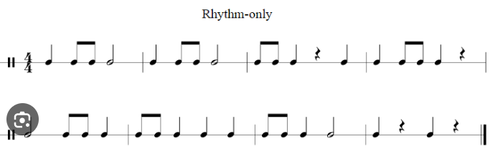
Reading rhythms


Ensemble conducting techniques

- Rhythm
- Chords
- Melody
- Ensemble
- Conducting
- Treble and Bass clef
- Harmony
- Genres
- Chord progressions

Developing Knowledge:
Knowledge |  | Working Towards | Within | Expected | Above
 | - To gain a comprehensive understanding of various musical concepts, including note recognition, sustain production, reading rhythms, and chord progressions.
Developing skills:
Skills |  | Working Towards | Within | Expected | Above
  Musicianship and performance | - Through practise and performance, students have enhance their musical skills, such as following rhythm and melody with play along-tracks, playing in small groups and developing ensemble conducting techniques.
  Composition | - Start to read and play simultaneous treble and bass clef notes, expanding musical possibilities and basic understanding of harmony.
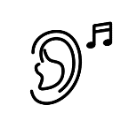  Listening | - Develop listening skills by exploring different genres, chord progressions, and emotions evoked by major and minor chords.
Evaluate |  | Working Towards | Within | Expected | Above
 | - To evaluate peer performances, discussing dynamics techniques and rhythmic and melodic accuracy.
Highlights: ___________________________________________________________________________________

_____________________________________________________________________________________________

