

Level 1

Music- Boomwhackers
Outcome: To produce percussive sounds and to play familiar pieces of music as a class orchestra.

Prior skills:
Prior skills from Reception:
- To confidently recognise some tuned and un-tuned instruments
- To develop a basic understanding of percussion instruments
- To identify preferences in music

Vocabulary:

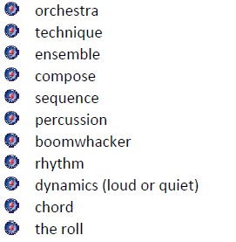

Ideas and inspiration:
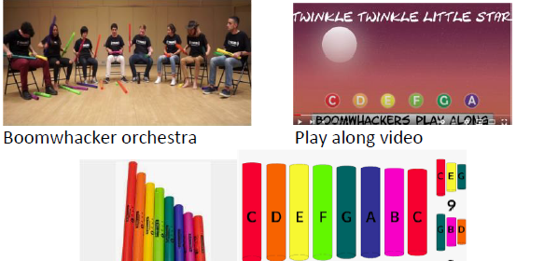

Developing Knowledge:
Knowledge |  | Working Towards | Within | Expected | Above
 | - To gain knowledge of the history and invention of the Boomwhacker, the different colours and corresponding notes, sustain and roll techniques, rhythm notation, and major and minor chords.
Developing skills:
Skills |  | Working Towards | Within | Expected | Above
  Musicianship and performance | - Through playing the Boomwhacker, to develop musicianship and performance skills, including timing, coordination, dynamics, ensemble playing, sustain and roll techniques, and stage presence.
  Composition | - To use a variety of musical components in one composition e.g. rhythm, melody.
  Listening | - To identify patterns of repetition, contrasts and variations and how these can be organised to give structure to melody, rhythm, dynamic and timbre.
Evaluate |  | Working Towards | Within | Expected | Above
 | - Offer constructive feedback and to reflect upon own performances.
Highlights: ___________________________________________________________________________________

_____________________________________________________________________________________________

