

History- The Ancient Greeks (Year 4)

Outcome: to create a Greek video news report.

Prior Knowledge
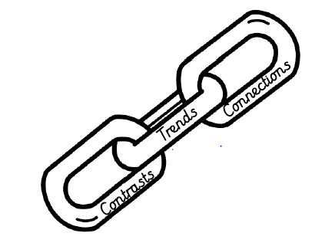 | - Compare early civilisations during the same period of time across the world.(Stone Age, Egyptians and Greeks)
Prior Skills
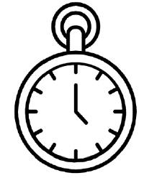 | - Understand and represent that the past can be divided into different periods of time. (AD/ BC)

Vocabulary:
- Acropolis
- Agoge
- Ancestors
- Architecture
- Democracy
- Olympics
- Legend
- Myth
- Philosophy
- Politician
- God/ Godess
- Prophecy

Ideas and inspiration:

Ancient Greek Day. Olive Crowns. Olympic Torches.

.


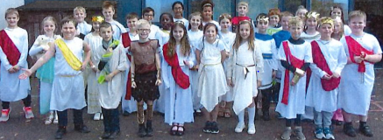

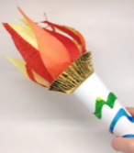

How did your Geography learning help you with your History? ___________________________________________
______________________________________________________________________________________________
Highlights: _____________________________________________________________________________________
______________________________________________________________________________________________

Developing Knowledge and Skills
Historical perspective |  | Working Towards | Within | Securely Within | Above
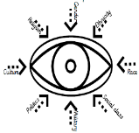 | - To know who the Greeks were and what influenced the way they lived their lives.
 | - To know what education was like during this period of time.
 | - To describe what was involved in early democracy.
 | - To know the origin of the Olympics and what this involved.
 | - To know what religion consisted of during the Ancient Greek, naming gods and goddesses.
Historical comparisons |  | Working Towards | Within | Securely Within | Above
 | - To compare early civilisations during the same time period across the world.
 | - To compare life today and during the Greek period.
Historical enquiry |  | Working Towards | Within | Securely Within | Above
 | - To explore historical evidence and draw conclusions by making supporting judgements of the past.  - Begin to develop an understanding of valid sources and how these tell us about life during Ancient Greece.
Historical chronology |  | Working Towards | Within | Securely Within | Above
 | - To represent that the past can be divided into different period of time (AD-BC)
 | - To use dates to place events, people and eras on a timeline including period we have already learnt about.

