
Hi

History- The Stone Age into The Iron Age (Year 3)

Outcome: to participate in Stone Age day, retelling and re-enacting key aspects of life during the Stone Age.

Prior Skills
Prior skills from The Great Fire of London and Significant people in the past.
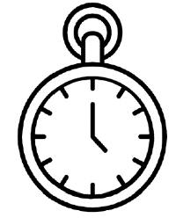   | - Use a range of historical sources (paintings/diary) and artefacts to identify what life was pre, post and during the Great Fire of London.
 | - Use words relating to the passing of time.
 | - Use timelines to sequence events.

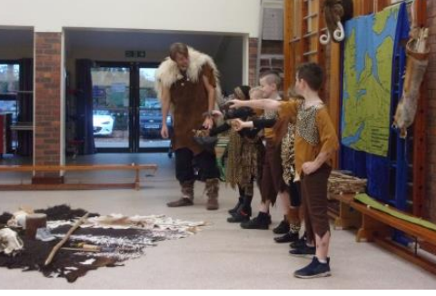
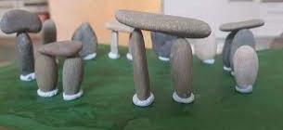
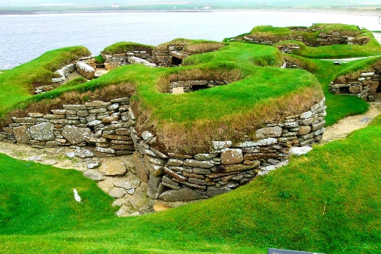
Ideas and inspiration:

.

Why is it important to learn about the past? _________________________________________________________
______________________________________________________________________________________________
Highlights: _____________________________________________________________________________________
______________________________________________________________________________________________

Developing Knowledge and Skills
Historical perspective |  | Working Towards | Within | Securely Within | Above
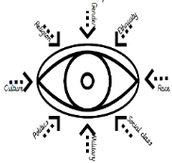 | - To know what life was like during the Stone Age.
 | - To know how people survived through hunting, farming and mining.
 | - To describe the features of settlements.
 | - To know what religion was and meant to people during the Iron Age to the Stone Age.
 | - To recognise Stone Henge and what it meant/s to people.
Historical comparisons |  | Working Towards | Within | Securely Within | Above
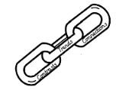 | - To compare life during the Stone Age Era to the developments of the Iron Age.
 | - To draw similarities and differences between modern day Britain and the Stone Age era.
Historical enquiry |  | Working Towards | Within | Securely Within | Above
 | - To explore evidence from Skara Brae and Stone Henge and what this tells us about the past.
 | - Use a range of historical artefacts (tools, clothing, paintings, house models etc.) to draw conclusions and make judgements about the past.
Historical chronology |  | Working Towards | Within | Securely Within | Above
 | - To show that the past is divided into different periods of time (AD/BC)
 | - To use dates to place events, people and eras on a timeline.

