
t

History- Ancient Egyptians (Year 3)
Outcome: To create Egyptian top trump cards using key historical figures and gods.

Prior Skills
Prior skills from The Great Fire of London and Significant people in the past.
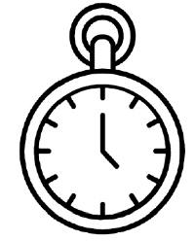   | - Know what life was like during the Stone age and compare it to modern day.
 | - Use words relating to the passing of time.
 | - Use timelines to sequence events.

Ideas and inspiration:

.

Vocabulary:

- Pyramid
- Excavate
- Merchant
- Mummy
- Pharaoh
- Hieroglyphics
- Scarab
- Shrine
- Tomb
- Nile

.

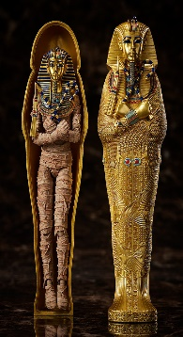
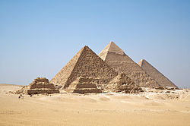
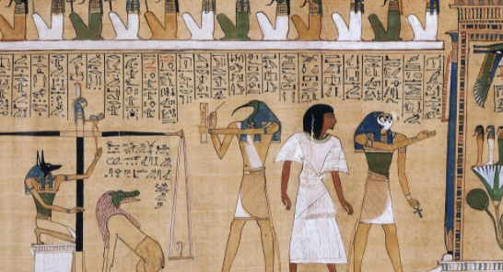

O c
Developing Knowledge and Skills
Historical perspective |  | Working Towards | Within | Securely Within | Above
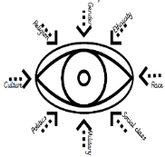 | - To know what everyday life was like for the Egyptians in early civilisation.
 | - To know what was important for people during this period of time
 | - To know and describe the process and importance of Mummification.
 | - To know who Tutankhamun was.
 | - To know Who the important Egyptian gods were and the powers they had
Historical comparisons |  | Working Towards | Within | Securely Within | Above
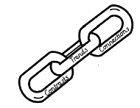 | - Compare life in early civilisations to life today.
 | - To draw upon similarities, exploring the impact early civilisation had on us today
Historical enquiry |  | Working Towards | Within | Securely Within | Above
- To use a range of historical sources to identify ways we know about the past
(drawings, hieroglyphics, artefact, tombs, mummification)
Historical chronology |  | Working Towards | Within | Securely Within | Above
 | - To show that the past is divided into different periods of time (AD/BC)
 | - To use dates to place events, people and eras on a timeline.

How did your Geography learning help you with your History? ___________________________________________
______________________________________________________________________________________________
Highlights: _____________________________________________________________________________________
______________________________________________________________________________________________

