

History- The Great Fire of London (Year 2)

Outcome: Understand the impact of the Great Fire of London on modern London.

Prior skills
Prior skills from Travel and Transport and Toys, past and present.
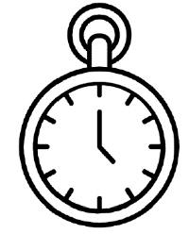   | - Use a selection of historical sources to make comparisons.
 | - Use sequencing and timelines to order events in the past.
 | - Use suggest similarities and differences between periods of time.

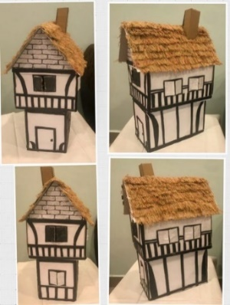
Ideas and inspiration:

Tudor houses. Pudding Lane-bread making.

Vocabulary:
- Thomas Farriner
- Monument
- Thatched Roof
- Wooden beams
- Diary
- Samuel Pepys
- The Tower of London
- Flames
- Ash
- River Thames
- Leather Bucket
- St Paul’s Cathedral

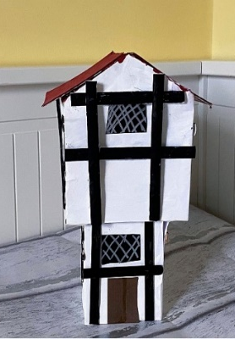
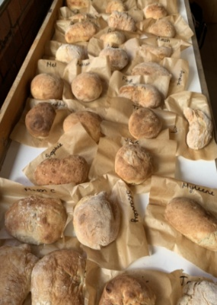

Developing Knowledge
Historical perspective |  | Working Towards | Within | Securely Within | Above
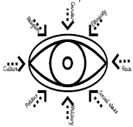 | - To know what the fire was, how it started and what impact it had on people lives
 | - To know who Samuel Pepys was and how he contributed to what we know today through his diary.
 | - To recognise features of London’s settlements and how these impacted the fire.
 | - To describe what life was like after the fire and how it impacted the future architecture.
Historical comparisons |  | Working Towards | Within | Securely Within | Above
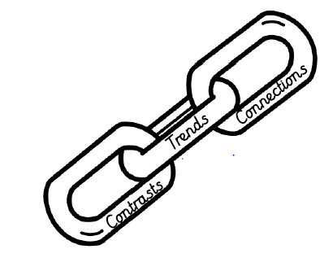 | - To compare life pre and post the Great Fire.
 | - To compare modern life to life during 1666.
Developing skills
Historical enquiry |  | Working Towards | Within | Securely Within | Above
 | - To use a range of historical sources (paintings/diary) and artefacts to identify what life was pre, post and during the Great Fire of London.
Historical chronology |  | Working Towards | Within | Securely Within | Above
 | - To progress in chronological understanding using timelines for the events of the 5 days of the Great Fire.
 | - To use dates to show when the fire was.
 | - To use phrases and common words relating to the passing of time.
How did you use your Geography and map skills to help you learn about the Great Fire of London? __________________
__________________________________________________________________________________________________
Highlights: _________________________________________________________________________________________
________________________________________________________________________________________________

