

History - Significant people in the past (Year 2)

Outcome: re-tell the contributions of Florence Nightingale and Mary Seacole.

Prior skills
Prior skills from Year 1.
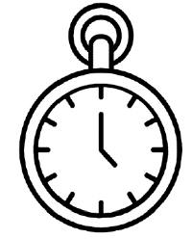   | - Use a selection of historical sources to make comparisons.
 | - Use sequencing and timelines to order events in the past.
 | - Use suggest similarities and differences between periods of time.

Ideas and inspiration:

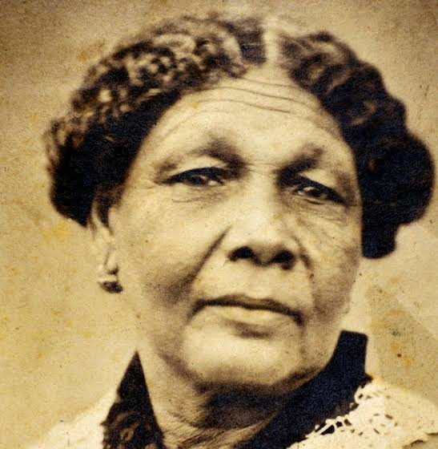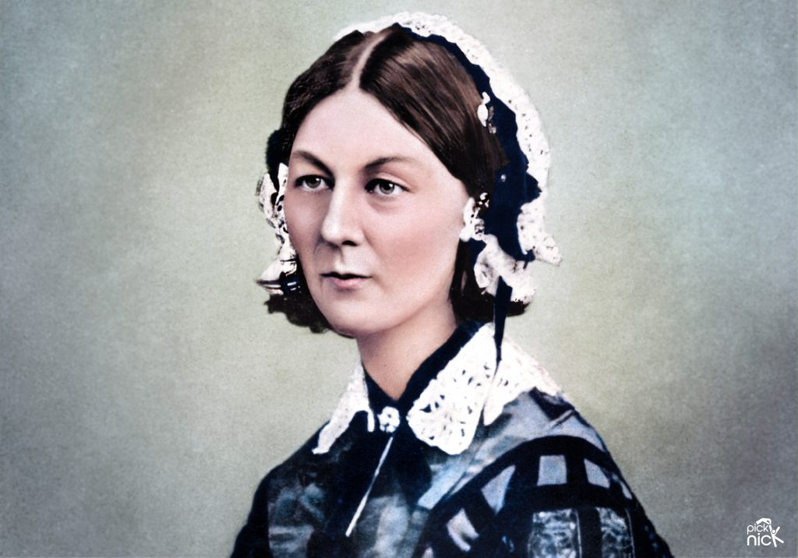
Mary Seacole Florence Nightingale

Amelia Earhart Neil Armstrong

Vocabulary:
- Florence Nightingale
- Mary Seacole
- nursing
- hygiene
- war
- achievement
- contribution
- significant
- revolutionised
- pioneer
- medicine
- soldiers
- healers

Developing Knowledge
Historical perspective |  | Working Towards | Within | Securely Within | Above
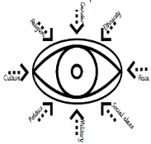 | - Know who Florence Nightingale and Mary Seacole were and what their lives were like.
 | - Know what factors contributed to their careers and later achievements.
 | - Know what they did to contribute to history and what makes them significant.
Historical comparisons |  | Working Towards | Within | Securely Within | Above
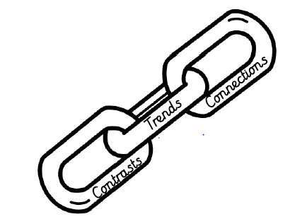 | - Compare significant people in the past and their achievements.
Developing skills
Historical enquiry |  | Working Towards | Within | Securely Within | Above
 | - Use a range of historical sources to identify ways we find out about the past.
Historical chronology |  | Working Towards | Within | Securely Within | Above
 | - Use a timeline to order and sequence events.
 | - Begin to use dates to compare periods of time and time in between dates.
 | - Use phrases and common words relating to the passing of time.
How can your learning help you research other significant people? ____________________________________________
__________________________________________________________________________________________________
Highlights: _________________________________________________________________________________________
__________________________________________________________________________________________________

