

History- Travel and Transport

Outcome: understand how travel and transport have changed throughout history

Prior skills
Prior skills from EYFS (Development matters)
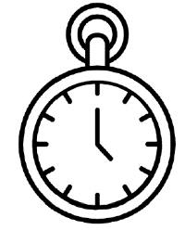   | - Use past and present to describe.
 | - Recognise significant figures and people.

Ideas and inspiration

Gatwick Airport. The First flight- The Wright Brothers.
Vocabulary:
- Travelling
- Transportation
- Old / New
- Horse and Cart
- Modern
- Cars
- Steam train
- Submarine
- Truck
- Living memory
- Hot Air Balloon
- Penny fathering

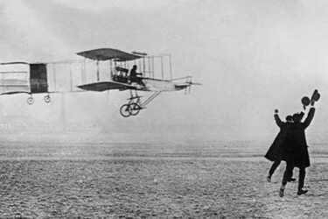

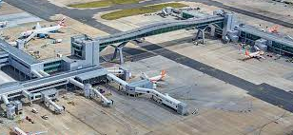
What is your favourite way to travel? __________________________________________________________________
_________________________________________________________________________________________________
Highlights: ________________________________________________________________________________________
_________________________________________________________________________________________________
Developing Knowledge
Historical perspective |  | Working Towards | Within | Securely Within | Above
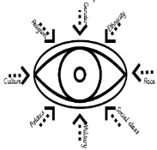 | - To know who the Wright brothers were and how they contributed to national and global achievement.
 | - To know who George Stephenson was and his achievements.
 | - To recognise the impact of transport to people’s lives and how people use transport in different ways.
Historical comparisons |  | Working Towards | Within | Securely Within | Above
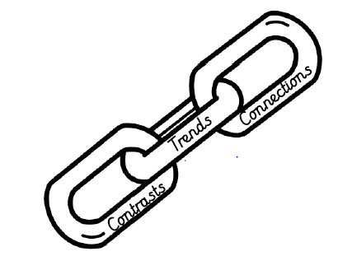 | - To compare types of transportation, identifying similarities and differences.
 | - To explore developments of transport over time.
Developing skills
Historical enquiry |  | Working Towards | Within | Securely Within | Above
 | - To use a range of historical sources to make comparisons between transport past and present (photos/artefacts)
Historical chronology |  | Working Towards | Within | Securely Within | Above
 | - To use a timeline to represent events in order.
- To build chronological skills and understanding by
sequencing a few events, pictures and objects.

