

History- Toys in the past (Year 1)
Outcome: to create a toy museum experience

Prior skills
Prior skills from EYFS
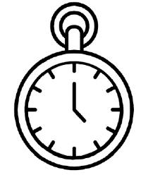   | - Recognise past and present
 | - Compare characters and figures from the past.

Vocabulary:
- Old
- New
- Victorian
- Entertainment
- Spinning top
- Crayola
- Abacus
- Lego
- Cup and ball
- Acrobat
- Slate and chalk

Ideas and inspiration
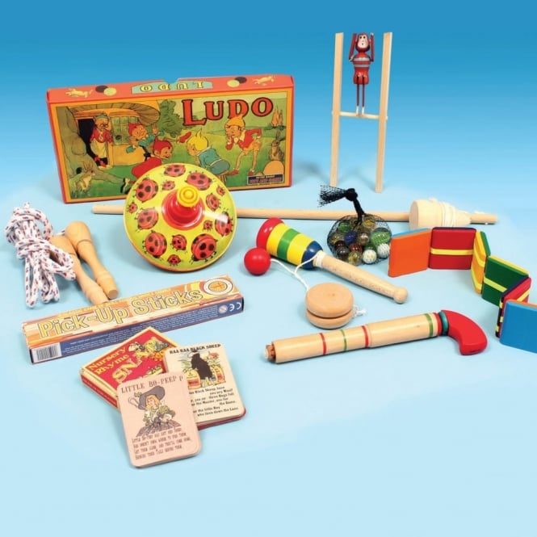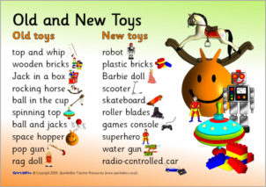

What was your favourite toy from the past? _____________________________________________________________
_________________________________________________________________________________________________
Highlights: ________________________________________________________________________________________
_________________________________________________________________________________________________
Developing Knowledge
Historical perspective |  |  | Working Towards | Within |  | Securely Within | Above
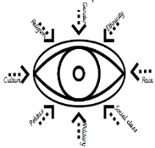 | - To explore how toys have changed over time.
 | - To name and identify toys past and present from their appearance, material and their uses.
 | - To identify different materials used over time to make toys
Historical comparisons |  |  | Working Towards | Within |  | Securely Within | Above
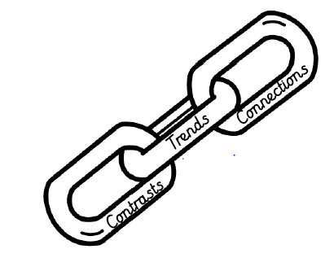 | - To compare toys in the past and present day.
- To explore developments of toys over time.
Evaluating their similarities and differences.
Developing skills
Historical enquiry |  |  | Working Towards | Within |  | Securely Within | Above
 | - To use a range of historical sources to make comparisons between toys (asking grandparents, looking at artefacts)
Historical chronology |  |  | Working Towards | Within |  | Securely Within | Above
 | - To use a timeline to represent events in order.
- To build chronological skills and understanding by
sequencing a few events, pictures and objects.
Quiz
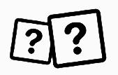 | Date
 | Score

