

History – compare and contrast characters from the past (Reception)
Outcome: To compare and contrast characters from the past focusing on significant people.

Prior skills
Prior skills from EYFS
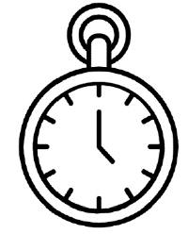   | - Recognise past and present
 | - Compare characters and figures from the past.

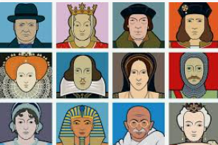
Vocabulary:
- Past
- Present
- Lived
- Living
- Royal
- Famous
- Living memory
- Remember
- The Queen
- The King
- Reign
- Coronation

Ideas and inspiration

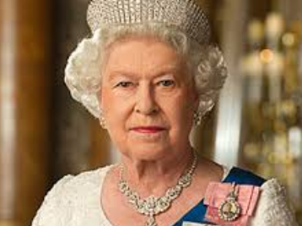

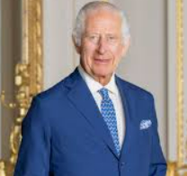

Developing Knowledge

Historical perspective |  | Emerging | Expected
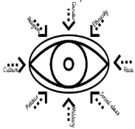 | - To explore and share texts and images that help children begin to develop an understanding of the past and present.  - Texts to feature fictional and non-fictional characters from a range of cultures and times in storytelling.
Historical comparisons |  | Emerging | Expected
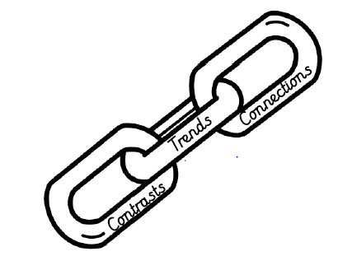 | - To comment on significant people, drawing similarities and differences between each.
Developing skills
Historical enquiry |  | Emerging | Expected
 | - To draw out common themes from stories, such as bravery, difficult choices and kindness, and talk about children’s experiences with these themes.
Historical chronology |  | Emerging | Expected
 | - To use a timeline to represent significant people from the past in order.
- To build chronological skills and understanding by
sequencing a few events, pictures and objects.

