

History – WWII (Year 6)

Outcome: To retell the events of WWII

Prior knowledge
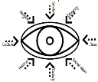  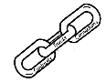 | - Recognise the Roman Empire invaded from Europe and this had an impact on Britain (Year 4)
 | - Recognise that significant people contribute to achievements in the past (Year 2)
- Compare life during periods of time.
Vocabulary:
Army, air raid, blackout, evacuees, gas mask, Hitler, Holocaust, Germany, Nazi, propaganda, propaganda, posters, rations, rationing, ration books, restrictions, siren, shelters, suitcase, spitfire victory, Winston Churchill.

Ideas and inspiration:

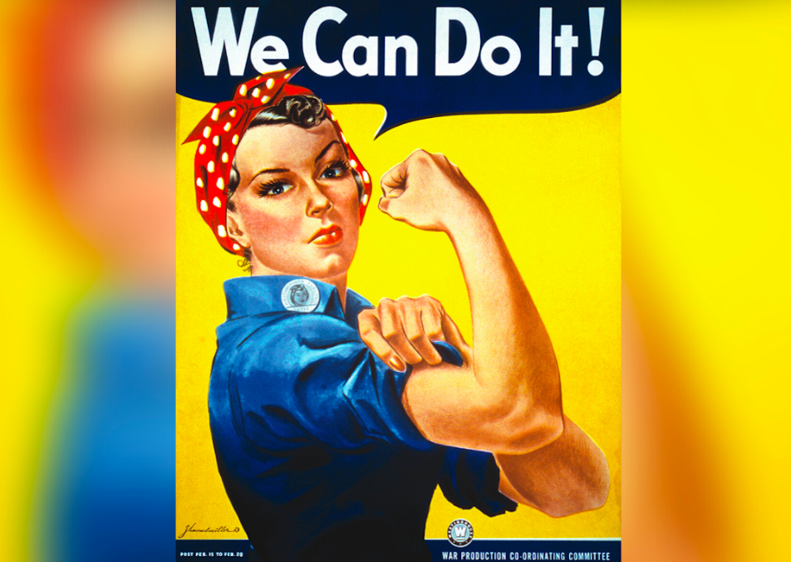

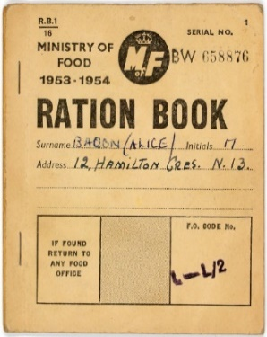
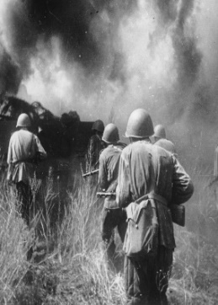

Developing Knowledge and Skills
Historical perspective |  | Working Towards | Within | Securely Within | Above
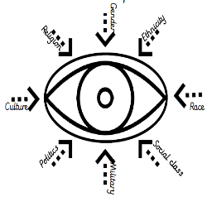 | - To appreciate the changes to life due to World War II including (rationing, entertainment, male and female roles and evacuation).
 | - To understand the war effort and people’s responsibilities.
 | - To know what life was like for different social classes and different groups of people during this time
 | - To recognise the outbreak and impact war had both nationally and globally.
Historical comparisons |  | Working Towards | Within | Securely Within | Above
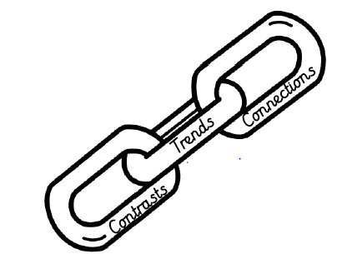 | - To compare life pre and post war.
 | - To draw connections, contrasts and trends between life today and during WWII using evidence to explain.
Historical enquiry |  | Working Towards | Within | Securely Within | Above
 | - Investigate life during the WWII by using a wide range of historical evidence to draw conclusions and make judgements about the past.
 | - Develop an understanding of valid sources and how these tell us about life during WWII.
Historical chronology |  | Working Towards | Within | Securely Within | Above
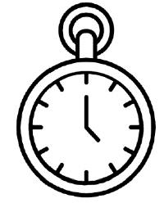 | - To use dates precisely.
 | - Describe characteristics of periods and societies studied and place them on a chronological framework such as a timeline.
Reflecting on your learning, is there anything you think was better in the 1940s than it is today? ________________
______________________________________________________________________________________________
Highlights: _____________________________________________________________________________________
______________________________________________________________________________________________

