

History - The Victorians (Year 6)

Outcome: Understand significant innovations of the Victorian era and how they changed our world.

Prior knowledge
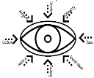  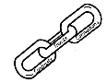 | - Recognise Victorian toys and transport (Year 1)
 | - Recognise that significant people contribute to achievements in the past (Year 2)
- Compare life during periods of time.
Vocabulary:
- camera
- chimney sweep
- inventions
- iron/tin
- mining
- poverty
- Prince Albert
- Queen Victoria
- rich and poor
- steam train
- The Industrial Revolution

Ideas and inspiration:

Victorian Steam train Penny Farthing

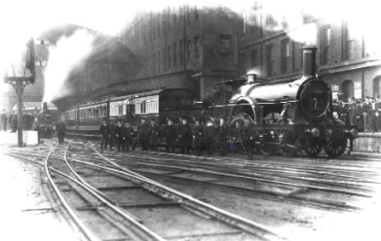
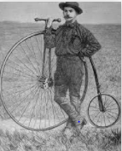

Developing Knowledge and Skills
Historical perspective |  | Working Towards | Within | Securely Within | Above
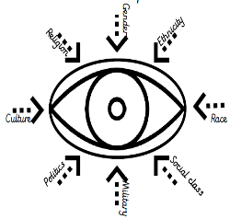 | - To know who the Victorians were, recognising some as famous (Queen Victoria)
 | - To understanding what life was like during the Victorian period? Focusing on the differences between social classes.
 | - To recognise Victorian inventions and how these impacted lives.
 | - To know features and the impact of the industrial revolution.
Historical comparisons |  | Working Towards | Within | Securely Within | Above
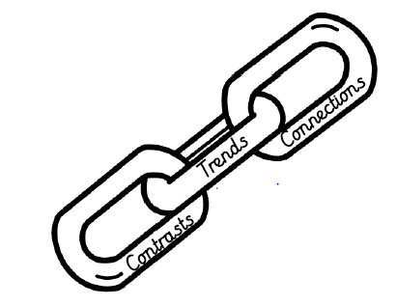 | - To compare life during the Victorian Era and today.
 | - To draw connections, contrasts and trends over time periods, using evidence to explain.
Historical enquiry |  | Working Towards | Within | Securely Within | Above
 | - Investigate life during the Victorian Era using a wide range of evidence to draw conclusions and make judgements
 | - Develop an understanding of valid sources and how these tell us about the life during the Victorian period.
Historical chronology |  | Working Towards | Within | Securely Within | Above
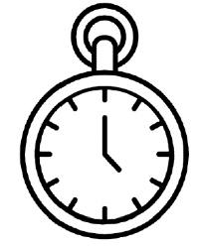 | - To use dates precisely.
 | - Describe characteristics of periods and societies studied and place them on a chronological framework such as a timeline.
How did your learning in Year 1 on the Victorians link to your learning in Year 6? ____________________________
______________________________________________________________________________________________
Highlights: _____________________________________________________________________________________
______________________________________________________________________________________________

