

History- The Anglo-Saxons to the Vikings (A study of invasion, kingdoms and settlements) (Year 5)
Outcome- to re-enact the invasion of the Anglo- Saxons and Vikings in Great Britain.

Outcome: Create an Anglo- Saxon settlement using common materials.

Prior knowledge
  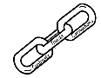 | - Recognise the common features of settlements during 1666 (The Great Fire of London)
 | - Recognise the features of settlements during the Stone Age to Iron Age
- Compare life during periods of time.
Vocabulary:
Angles, archaeological, armoury, Bretwalda, Britons, blood-fued, Celts, conquer, dooms, Danelaw, Kingdom, King Alfred, long boats, Jutes, raids, Picts, settlements.

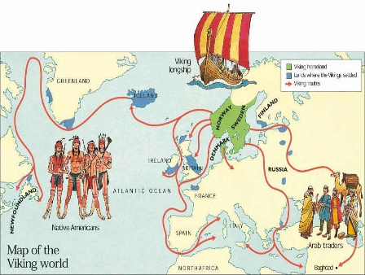
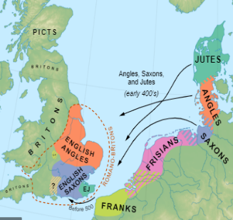
Ideas and inspiration:

Invasion of the Anglo-Saxons Invasion of the Vikings

Reflecting on your learning in History this year, who do you think was the most successful invader and settler? Why do you think this? ______________________________________________________________________________________
Highlights:______________________________________________________________________________________
Developing Knowledge and Skills
Historical perspective |  | Working Towards | Within | Securely Within | Above
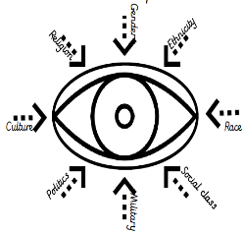 | - To know what the invasion and raid of the Vikings from the Anglo-Saxons was and consisted of.
 | - To name and reason for the 7 kingdoms.
 | - To identify the features of typical settlements during Anglo-Saxon Britain and compare these to changes post Viking invasion in Danelaw (Easter England)
 | - To recognise the impact of the law/legal system, the Early Monarchs and religion during this time.
 | - To know features of everyday life during this era.
 | - To understand and explain the ending of the Saxon and Viking rule of Britain (Normans , Harold and Battle of Hastings)
Historical comparisons |  | Working Towards | Within | Securely Within | Above
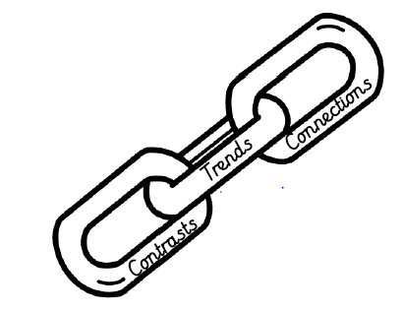 | - To compare life from AD 449-1066. Exploring the impact this had on Britain past and present.
 | - To make connections, contrasts and trends over time periods.
Historical enquiry |  | Working Towards | Within | Securely Within | Above
 | - To explore life during the Saxon/ Viking period of invasion by using a selection of artefacts and valid sources.
 | - To draw conclusions using supporting evidence based on validity.
Historical chronology |  | Working Towards | Within | Securely Within | Above
 | - To use dates precisely including AD and BC. Say, read and writing them accurately.
 | - To have a secure understanding of chronology of British, local and international history studied.

