

History - The Romans (Year 4)

Outcome: To use knowledge of the Romans to design and create Roman roads and settlements.

Prior Knowledge
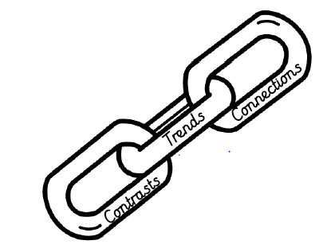 | - Compare early civilisations during the same period of time across the world.(Stone Age, Egyptians and Greeks)
Prior Skills
 | - Understand and represent that the past can be divided into different periods of time. (AD/ BC)  - Draw upon similarities, exploring the impact early civilisation had on us today

Vocabulary:
- Celts
- Boudicca
- settlement
- raids
- chariot
- Empire
- Emperor
- religion
Ideas and inspiration:
Roman roads The invasion of the Roman Empire.
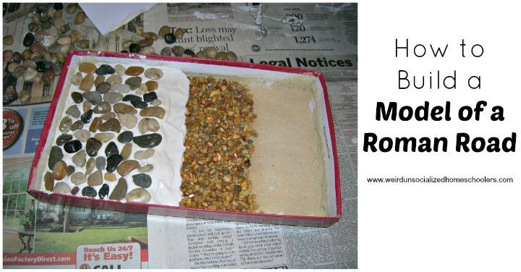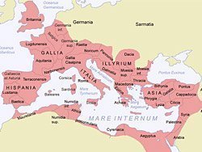

.

Developing Knowledge and Skills
Historical perspective |  | Working Towards | Within | Securely Within | Above
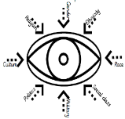 | - To know that the Roman Empire invaded from Europe and this had an impact on Britain (link to geography in Year 3)
 | - To know what life was like during this Era (settlements, food, education, numerals)
 | - To know that the Romans had an impact on travel and transport in Roman Britain (make roads)
 | - To know and understand the role of Boudicca.
 | - To understand the development and building of Hadrian’s Wall.
Historical comparisons |  | Working Towards | Within | Securely Within | Above
 | - To compare life during the Roman era and today (differences in settlements, education and food/drink, people’s names)
 | - To use prior knowledge to compare the Roman Era to those previously taught. (Greeks and Egyptians)
Historical enquiry |  | Working Towards | Within | Securely Within | Above
 | - To explore historical evidence and draw conclusions by making supporting judgements of the past.  - Begin to develop an understanding of valid sources and how these tell us about life during the reign of the Roman Empire.
Historical chronology |  | Working Towards | Within | Securely Within | Above
 | - To represent that the past can be divided into different period of time (AD-BC)
 | - To use dates to place events, people and eras on a timeline, including period we have already learnt about.
How will learning about the Romans help you when you learn about the Anglo Saxons next year? _______________
______________________________________________________________________________________________
Highlights: _____________________________________________________________________________________
______________________________________________________________________________________________

